**UVM project - Synchronous FIFO**

**Abdelrahman Mohamed Ali**

**7 May, 2024**

|  |  |
| --- | --- |
| **Gmail** | [**abdelrahmansalby23@gmail.com**](mailto:abdelrahmansalby23@gmail.com) |
| **LinkedIn** | [**Abdelrahman Mohamed**](https://www.linkedin.com/in/abdelrahman-mohamed-814a9022a/) |
| **GitHub** | [**Abdelrahman1810**](https://github.com/Abdelrahman1810?tab=repositories) |

**Please see readme.md file first**

**Note: if you use VS code use shortcut ‘ ctrl+shift+v ‘ so you can see the file with GUI**

**Verification Plane**

1. Activate reset at the first 5 cycle.
2. LOCK RESET
3. Write only to make FIFO full.
4. Write when FIFO full.
5. Read times less than FIFO_DEPTH.
6. read and write constraint WRITE DIST MORE THAN READ.
   * the first loop to make data_in constraint one bit high
   * the seconed loop with no constraint at data_in
7. Apply Sync toggle => read and write will be equal but they are not equal to the same value twice in a row.
8. Read only to make FIFO empty.
9. Read when FIFO empty.
10. Write only to make FIFO before full.
11. Apply Async toggle => read and write will be not equal but they are not equal to the same value twice in a row.
12. Read Only.
13. write Only.
14. UNLOCK RESET
15. Apply read and write at the same time WRITE DIST LESS THAN READ.
    * the first loop to make data_in constraint one bit high
    * the seconed loop with no constraint at data_in
16. Activate reset.
17. Randomization with no Constraint.

|  |  |  |  |  |
| --- | --- | --- | --- | --- |
| Label | Description | Stimulus Generation | Functional Coverage | Functionality Check |
| FIFO_1 | asserted the reset at the first 5 clk cycle | Randomization with post_randomize dunction to make sure that at the first 5 clk cycle the reset will be low | included in covergroup CVG in coverpoint of reset named "rst_cp" | ______ |
| FIFO_2 | Case: reset activated Check the sequential signal (wr_ack, overflow, underflow, data_out) should be zero | Randomization with post_randomize dunction to make sure that at the first 5 clk cycle the reset will be low | included as a coverpoint of reset and wr_ack, overflow, underflow, data_out  included as a cross coverage to check that signal will be in active when reset is active | Output Checked against golden model and checked with combinational assertion (label: assert_wr_akc_rst  assert_overflow_rst  assert_underflow_rst  assert_data_out_rst) |
| FIFO_3 | Case: reset is activated the internal signal (wr_otr, rd_ptr and count) should be inactive | Randomization with post_randomize dunction to make sure that at the first 5 clk cycle the reset will be low | included as a coverpoint of rst_n  No coverage for internal signal | Output checked with assertion (label: assert_count_rst,  assert_wr_ptr_rst,  assert_rd_ptr_rst) |
| FIFO_4 | make reset Inactive most of the time | Randomization under constraint (label: CON_RESET) to make rst_n is active => 95%, and rst_n is Inactive => 5% | included in covergroup CVG in coverpoint of reset named "rst_cp" | ______ |
|  |  |  |  |  |
| FIFO_5 | Case: wr_en = 1, rd_en = 0,  full = 0, empty = 0.  1.Write operation done  2.wr_ack gets high  3.if count ==FIFO_DEPTH-1  4.then almostfull gets high | Randomization under constraint (label: CON _W) that constraint wr_en to be active and rd_en to be inactive | Included a coverpoint wr_ack_cp.  Included a coverpoint almostfull_cp.  Included a cross almostfull & wr_en.  Included a cross coverage wr_ack & wr_en. | Output  Checked against golden model  Checked by assertion Label: **ack_active,**  **almostfull_count** |
| FIFO_6 | Case: wr_en = 1, rd_en = 0,  full = 1.  1.Write operation ignored  2.wr_ack gets low  3.overflow gets high | Randomization under constraint (label: CON _W) that constraint wr_en to be active and rd_en to be inactive | Included a coverpoint overflow_cp  Included a cross coverage overflow & wr_en. | Output  Checked against golden model  Checked by assertion label:  **ack_inactive**  **overflow_active** |
| FIFO_7 | Case: wr_en = 1, rd_en = 0,  empty = 1.  1.Write operation done  2.wr_ack gets high  3.empty gets low  4.almostempty gets high | Randomization under constraint (label: CON _W) that constraint wr_en to be active and rd_en to be inactive | Included a coverpoint wr_ack_cp.  Included a coverpoint for empty.  Included a coverpoint almostempty_cp.  Included a cross coverage wr_ack & empty (ack_empty_cross)  Included a cross coverage almostempty & empty (almostempty_empty_cross) | Output  Checked against golden model  Checked by assertion Label:  **ack_active,**  **empty_inactive,**  **almostempty_from_empty** |
| FIFO_8 | Case: wr_en = 1, rd_en = 0,  almostfull = 1.  1.Write operation done  2.wr_ack gets high  3.almostfull gets low  4.count == FIFO_DEPTH so full gets high | Randomization under constraint (label: CON _W) that constraint wr_en to be active and rd_en to be inactive | Included a coverpoint wr_ack_cp.  Included a coverpoint full_cp.  Included a coverpoint almostfull_cp.  Included a cross coverage wr_ack & full (ack_full_wr_cross)  Included a cross coverage almostfull & full (almostfull_full_cross) | Output  Checked against golden model  Checked by assertion Label:  **ack_inactive, almostempty_inactive,**  **full_count** |
| FIFO_9 | Case: wr_en = 1, rd_en = 0,  almostempty = 1.  1.Write operation done  2.wr_ack gets high  almostempty gets low | Randomization under constraint (label: CON _W) that constraint wr_en to be active and rd_en to be inactive | Included a coverpoint wr_ack_cp.  Included a coverpoint almostempty_cp.  Included a cross coverage wr_ack & empty (ack_empty_cross)  Included a cross coverage almostempty & wr_ack (ack_almostempty_cross) | Output  Checked against golden model  Checked by assertion Label:  **almostempty_inactive** |
|  |  |  |  |  |
| FIFO_10 | Case: wr_en = 0, rd_en = 1, empty = 0, full = 0.  1.Read operation done  2.check data_out | Randomization under constraint (label: CON _R) that constraint wr_en to be inactive and rd_en to be active | Included a coverpoint data_out_cp.  Included a cross coverage data_out &rd_en | Output  Checked against golden model  Checked by assertion Label:  **almostempty_count** |
| FIFO_11 | Case: wr_en = 0, rd_en = 1, empty = 1.  1.Read operation ignored  2.Underflow gets high | Randomization under constraint (label: CON _R) that constraint wr_en to be inactive and rd_en to be active | Included a coverpoint underflow_cp  Included a cross coverage:  underflow &rd_en, underflow &empty | Output  Checked against golden model  Checked by assertion Label:  **underflow_active** |
| FIFO_12 | Case: wr_en = 0, rd_en = 1, full = 1.  1.Read operation done  2.Check data_out  3.full gets low  4.almostfull gets high | Randomization under constraint (label: CON _R) that constraint wr_en to be inactive and rd_en to be active | Included a coverpoint data_out_cp.  Included a coverpoint full_cp.  Included a coverpoint almostfull_cp. Included a cross coverage almostfull & full (almostfull_full_cross) | Output  Checked against golden model  Checked by assertion Label:  **almostfull_from_full** |
| FIFO_13 | Case: wr_en = 0, rd_en = 1, almostempty = 1.  1.Read operation done  2.Checked data_out  3.almostempty gets low  4.empty gets high | Randomization under constraint (label: CON _R) that constraint wr_en to be inactive and rd_en to be active | Included a coverpoint data_out_cp.  Included a coverpoint emoty_cp.  Included a coverpoint almostempty_cp.  Included a cross coverage almostempty & empty (ack_empty_cross) | Output  Checked against golden model  Checked by assertion Label:  **empty_from_almost** |
| FIFO_14 | Case: wr_en=0, rd_en = 1, almostfull = 1.  1.Read operation done  2.Checked data_out  3.almostfull gets low | Randomization under constraint (label: CON _R) that constraint wr_en to be inactive and rd_en to be active | Included a coverpoint almostfull_cp. Included a cross coverage almostfull &rd_en (almostfull_cross) | Output  Checked against golden model  Checked by assertion Label:  **almostfull_inactive** |
|  |  |  |  |  |
| FIFO_15 | Case: wr_en=1, rd_en=1, full = 0, empty = 0.  1.write operation done  2.wr_ack gets high  3.read operation done  4.checked data_out  5.Count will not change | Randomization under constraint (label: CON_BOTH_ACTIVE) that constraint wr_en to be inactive and rd_en to be active | Included a coverpoint wr_ack_cp  Included a coverpoint data_out_cp  Included a cross coverage:  wr_ack & wr_en (ack_wr_rd_cross).  data_out&wr_en&rd_en (data_out_cross). | Output  Checked against golden model  Checked by assertion Label:  **ack_active,**  **count_noChange** |
| FIFO_16 | Case: wr_en=1, rd_en=1, full = 1.  1.write operation ignored  2.wr_ack gets low  3.read operation done  4.checked data_out  5.full gets low  6.almostfull gets high  7.overflow gets high  8.count will decrement. | Randomization under constraint (label: CON_BOTH_ACTIVE) that constraint wr_en to be inactive and rd_en to be active | Included a coverpoint data_out_cp.  Included a coverpoint full_cp.  Included a coverpoint almostfull_cp.  Included a coverpoint overflow_cp.  Included a cross coverage:  data_out&wr_en&rd_en (data_out_cross).  almostfull & full (almostfull_full_cross)  overflow& full (full_overflow_cross) | Output  Checked against golden model  Checked by assertion Label:  **ack_inactive,**  **full_inactive,**  **almostfull_from_full,**  **overflow_active,**  **count_dec** |
| FIFO_17 | Case: wr_en=1, rd_en=1, empty = 1.  1.write operation done  2.wr_ack gets high  3.read operation ignored  4.empty gets low  5.almostempty gets high  6.underflow gets high  7.count will increment. | Randomization under constraint (label: CON_BOTH_ACTIVE) that constraint wr_en to be inactive and rd_en to be active | Included a coverpoint data_out_cp.  Included a coverpoint wr_ack_cp.  Included a coverpoint emoty_cp.  Included a coverpoint almostempty_cp.  Included a coverpoint underflow_cp.  Included a cross coverage:  data_out&wr_en&rd_en (data_out_cross).  underflow & emoty (empty_underflow_cross)  emoty & almostempty (almostempty_empty_cross)  wr_ack&wr_en&rd_en (ack_wr_rd_cross) | Output  Checked against golden model  Checked by assertion Label:  **ack_active,**  **empty_inactive,**  **almostempty_from_empty,**  **underflow_active,**  **count_inc** |
| FIFO_18 | Case: wr_en=1, rd_en=1, almostfull = 1.  1.write operation done  2.wr_ack gets high  3.read operation done  4.checked data_out  5. almostfull remain high  6.count remain the same. | Randomization under constraint (label: CON_BOTH_ACTIVE) that constraint wr_en to be inactive and rd_en to be active | Included a coverpoint data_out_cp.  Included a coverpoint wr_ack_cp.  Included a cross coverage:  data_out&wr_en&rd_en (data_out_cross).  wr_ack&wr_en&rd_en (ack_wr_rd_cross) | Output  Checked against golden model  Checked by assertion Label:  **ack_active,**  **almostfull_noChange,**  **count_noChange** |
| FIFO_19 | Case: wr_en=1, rd_en=1, almostempty = 1.  1.write operation done  2.wr_ack gets high  3.read operation done  4.checked data_out  5. almostempty remain high  6.count remain the same. | Randomization under constraint (label: CON_BOTH_ACTIVE) that constraint wr_en to be inactive and rd_en to be active | Included a coverpoint data_out_cp.  Included a coverpoint wr_ack_cp.  Included a cross coverage:  data_out&wr_en&rd_en (data_out_cross).  wr_ack&wr_en&rd_en (ack_wr_rd_cross) | Output  Checked against golden model  Checked by assertion Label:  **ack_active,**  **almostempty_noChange,**  **count_noChange** |
|  |  |  |  |  |

**Verification flow in waveform**

Write only

Read only

write only

Read probability higher than Write

Read only

Write only

**sync. Toggle**

Read only

Write probability higher than Read

**rst**

**rst**

**No constraint**

**Async. Toggle**

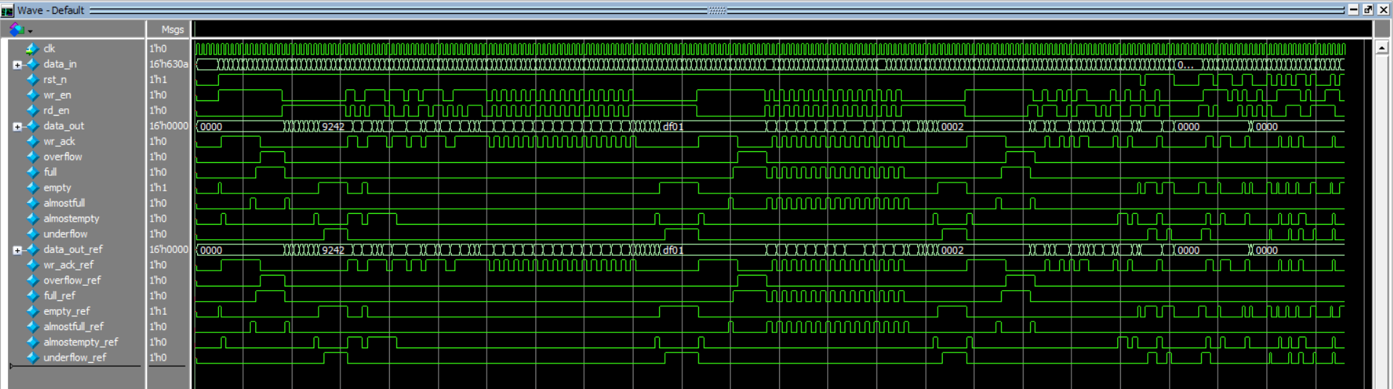

**UVM FLOW**

1. create defnitions.svh contain all defnithion macro i have used in the program
2. creat shared_pkg.sv that have shared variable and sequence for assertion
3. creat interface
4. add FIFO.sv design file in DUT folder
5. creat a golden model to check the DUT output
6. creat an assertion file
7. create top.sv file
   * pass the data from interface to DUT and refrence model
   * bind file assertion to design
   * set the virtual interface to data base
   * run UVM test
8. create configration class so can get virtul interface by
9. create sequence_item
   * add the variable and rand variable
   * creat tow methods {print_DUT(), print_REF()}
   * creat a constraint block
10. create 9 FIFO_sequence so can verify the design
    * write_only_sequence
    * read_only_sequence
    * write_read_sequence
    * sync_toggle_sequence
    * Async_toggle_sequence
    * rst_sequence
    * random_sequence
11. create a driver.sv file
    * create avirtual interface between driver and real interface
    * make driver a producer get_data
    * assigned data from sequenceItem and pass it to interface inputs
12. create a monitor.sv file
    * create avirtual interface between monitor and real interface
    * assigned data from virtual interface and pass it to monitor object from sequenceItem inputs and outputs
    * create analysis_port to send data to agent
13. create a sequencer
14. create an agent.sv
    * get confegration object from data base and pass it to monitor and driver
    * make connection between monitor and agent to send data to scoreboard and cover_collector
    * make connection between sequencer and driver
15. create env.sv
    * create component {agent, scoreboard, cover_collector}
    * connect between agent and {scoreboard, cover_collector}
16. create test.sv file
    * get virtual interface an pass it to env
    * creat object from sequences
    * call bult-in function raise_objection to indecate that test is start
    * run sequences object in run_phase with specific sequence I have explaned in pdf
    * creat component for env
    * call bult-in function drop_objection to indecate that test is finished

**/// Do file**

vlib work

vlog -coveropt 3 +cover +acc {Codes\shared_pkg\shared_pkg.sv}

###

vlog -coveropt 3 +cover +acc {Codes\Interface\interface.sv}

vlog -coveropt 3 +cover +acc {Codes\refrence\FIFO_ref.sv}

###

vlog -coveropt 3 +cover +acc {Codes\DUT\FIFO.sv}

vlog +define+LOOK_ASSERTION -coveropt 3 +cover +acc {DUT\assertion.sv}

###

vlog -coveropt 3 +cover +acc {Codes\objects\configration.sv}

#vlog -coveropt 3 +cover +acc {Codes\objects\sequence_Items\sequenceItem_Valid.sv}

vlog -coveropt 3 +cover +acc {Codes\objects\sequence_Item\sequenceItem.sv}

vlog -coveropt 3 +cover +acc {Codes\objects\FIFO_sequence\FIFO_reset_sequence.sv}

vlog -coveropt 3 +cover +acc {Codes\objects\FIFO_sequence\FIFO_write_only_sequence.sv}

vlog -coveropt 3 +cover +acc {Codes\objects\FIFO_sequence\FIFO_read_only_sequence.sv}

vlog -coveropt 3 +cover +acc {Codes\objects\FIFO_sequence\FIFO_write_read_sequence.sv}

vlog -coveropt 3 +cover +acc {Codes\objects\FIFO_sequence\FIFO_sync_toggle_sequence.sv}

vlog -coveropt 3 +cover +acc {Codes\objects\FIFO_sequence\FIFO_Async_toggle_sequence.sv}

vlog -coveropt 3 +cover +acc {Codes\objects\FIFO_sequence\FIFO_random_sequence.sv}

###

vlog -coveropt 3 +cover +acc {Codes\UVM_top\Test\env\agent\driver\driver.sv}

vlog -coveropt 3 +cover +acc {Codes\UVM_top\Test\env\agent\monitor\monitor.sv}

vlog -coveropt 3 +cover +acc {Codes\UVM_top\Test\env\agent\sequencer\sequencer.sv}

vlog -coveropt 3 +cover +acc {Codes\UVM_top\Test\env\agent\agent.sv}

###

vlog -coveropt 3 +cover +acc {Codes\UVM_top\Test\env\coverage_collector\coverage_collector.sv}

vlog -coveropt 3 +cover +acc {Codes\UVM_top\Test\env\scoreboard\scoreboard.sv}

vlog -coveropt 3 +cover +acc {Codes\UVM_top\Test\env\env.sv}

###

vlog -coveropt 3 +cover +acc {Codes\UVM_top\Test\test.sv}

vlog -coveropt 3 +cover +acc {Codes\UVM_top\top.sv}

#vsim -voptargs=+acc work.top -classdebug -uvmcontrol=all

vsim +UVM_VERBOSITY=UVM_LOW -voptargs=+acc work.top -classdebug -uvmcontrol=all -cover

add wave -position insertpoint sim:/top/intf/*

run -all

#quit -sim

/// Defines

`define OFF_ALL item.constraint_mode(0);

`define ON(constraint) item.constraint.constraint_mode(1);

`define create_comp(type, name) type::type_id::create(name, this);

`define create_obj(type, name) type::type_id::create(name);

`define asrt_prp(content) assert property (@(posedge clk) disable iff(!rst_n) (content));

`define cov_prp(content) cover property (@(posedge clk) disable iff(!rst_n) (content));

`define asrt_fn assert final

`define cov_fn cover final

`define same_seq (rd_en && wr_en && !empty && !full)

`define Func_new_p(name_) \

function new(string name = name_, uvm_component parent = null); \

    super.new(name, parent); \

endfunction //new()

`define Func_new(name_) \

function new(string name = name_); \

    super.new(name); \

endfunction //new()

/// Interface

interface FIFO_interface (clk);

import shared_pkg::*;

input bit clk;

logic [FIFO_WIDTH-1:0] data_in;

logic rst_n, wr_en, rd_en;

logic [FIFO_WIDTH-1:0] data_out;

logic wr_ack, overflow;

logic full, empty, almostfull, almostempty, underflow;

logic [FIFO_WIDTH-1:0] data_out_ref;

logic wr_ack_ref, overflow_ref;

logic full_ref, empty_ref, almostfull_ref, almostempty_ref, underflow_ref;

endinterface //FIRO_interface

**/// shared pkg**

package shared_pkg;

`include "defines/defines.svh"

parameter FIFO_WIDTH = 16;

parameter FIFO_DEPTH = 8;

parameter RANGE = (2**FIFO_WIDTH) - 1;

parameter ACTIVE = 1;

parameter INACTIVE = 0;

int WR_EN_ON_DIST = 70;

int RD_EN_ON_DIST = 30;

int RESET_ACTIVE = 5;

int WR_START_VALUE_OF_TOGGLE = 1;

parameter ZERO = 0;

parameter MAX = (2**FIFO_DEPTH) - 1;

reg [FIFO_WIDTH-1:0] one_bit_high [16] = '{16'h1, 16'h2, 16'h4, 16'h8, 16'h10, 16'h20, 16'h40, 16'h80,

                                    16'h100, 16'h200, 16'h400, 16'h800, 16'h1000, 16'h2000, 16'h4000, 16'h8000};

int error_counter = 0;

int correct_counter = 0;

int inc_correct_counter = 0;

parameter DEPTH_LOOP = FIFO_DEPTH * 2;

parameter BEFORE_ALMOST = FIFO_DEPTH - 2;

parameter HOBBIT_LOOP = 5_00;

parameter DWARF_LOOP = 10_00;

parameter HUMAN_LOOP = 20_00;

parameter GIANT_LOOP = 30_00;

parameter BOOM_LOOP = 50_00;

/*

isFIRST_DIST_FINITH

this parameter as a flag: when sequence FIFO_write_read_sequence call for the first time in uvm_test

will make WRITE active more probability than READ then isFIRST_DIST_FINITH get high for the seconed time

uvm_test call sequence FIFO_write_read_sequence will make READ active more probability than WRITE

*/

bit isFIRST_DIST_FINITH = 0;

bit isFirstRead = 0;

bit isWriteTOfull = 0;

// Sequences

sequence A_A(Active1, Active2);

  (Active1 && Active2);

endsequence

sequence A_I(Active, Inactive);

  (Active && !Inactive);

endsequence

sequence AA_I(Active1, Active2, Inactive);

  (Active1 && Active2 && !Inactive);

endsequence

sequence A_II(Active, Inactive1, Inactive2);

  (Active && !Inactive1 && !Inactive2);

endsequence

endpackage

**/// FIFO_ref.sv**

import shared_pkg::*;

module FIFO_ref(data_in, wr_en, rd_en, clk, rst_n, full, empty, almostfull, almostempty, wr_ack, overflow, underflow, data_out);

    input [FIFO_WIDTH-1:0] data_in;

    input clk, rst_n, wr_en, rd_en;

    output reg [FIFO_WIDTH-1:0] data_out;

    output reg wr_ack, overflow, underflow;

    output full, empty, almostfull, almostempty;

    reg [FIFO_WIDTH-1:0] fifoo_q [$];

    // Write

    always @(posedge clk or negedge rst_n) begin

        if (!rst_n) begin

            fifoo_q.delete();

            wr_ack <= 0;

            overflow <= 0;

        end

        else if (wr_en && !full) begin

            fifoo_q.push_back(data_in);

            wr_ack <= 1;

            overflow <= 0;

        end

        else begin

            wr_ack <= 0;

            if (full && wr_en)

                overflow <= 1;

            else

                overflow <= 0;

        end

    end

    // Read

    always @(posedge clk or negedge rst_n) begin

        if (!rst_n) begin

            fifoo_q.delete();

            underflow <= 0;

            data_out <= 0;

        end

        else if (rd_en && !empty) begin

            data_out <= fifoo_q.pop_front();

            underflow <= 0;

        end

        else begin

            if (empty && rd_en)

                underflow <= 1;

            else

                underflow <= 0;

        end

    end

    assign almostfull = (fifoo_q.size() == FIFO_DEPTH-1 && rst_n)? 1:0;

    assign full = (fifoo_q.size() >= FIFO_DEPTH && rst_n)? 1:0;

    assign empty = (fifoo_q.size() == 0 && rst_n)? 1:0;

    assign almostempty = (fifoo_q.size() == 1 && rst_n)? 1:0;

endmodule

**/// FIFO.sv**

import shared_pkg::*;

`include "defines/defines.svh"

module FIFO(data_in, wr_en, rd_en, clk, rst_n, full, empty, almostfull, almostempty, wr_ack, overflow, underflow, data_out);

input [FIFO_WIDTH-1:0] data_in;

input clk, rst_n, wr_en, rd_en;

output reg [FIFO_WIDTH-1:0] data_out;

output reg wr_ack, overflow, underflow;

output full, empty, almostfull, almostempty;

localparam max_fifo_addr = $clog2(FIFO_DEPTH);

reg [FIFO_WIDTH-1:0] mem [FIFO_DEPTH-1:0];

reg [max_fifo_addr-1:0] wr_ptr, rd_ptr;

reg [max_fifo_addr:0] count;

always @(posedge clk or negedge rst_n) begin

    if (!rst_n) begin

        wr_ptr <= 0;

        wr_ack <= 0; // FIX

        overflow <= 0; // FIX

    end

    else if (wr_en && count < FIFO_DEPTH) begin

        mem[wr_ptr] <= data_in;

        wr_ack <= 1;

        wr_ptr <= wr_ptr + 1;

        overflow <= 0; // FIX

    end

    else begin

        wr_ack <= 0;

        if (full && wr_en)// FIX

            overflow <= 1;

        else

            overflow <= 0;

    end

end

always @(posedge clk or negedge rst_n) begin

    if (!rst_n) begin

        rd_ptr <= 0;

        underflow <= 0;// FIX

        data_out <= 0;// FIX

    end

    else if (rd_en && count != 0) begin

        data_out <= mem[rd_ptr];

        rd_ptr <= rd_ptr + 1;

        underflow <= 0; // FIX

    end

    else begin // FIX

        if (empty && rd_en)// FIX

            underflow <= 1;// FIX

        else // FIX

            underflow <= 0;// FIX

    end // FIX

end

always @(posedge clk or negedge rst_n) begin

    if (!rst_n) begin

        count <= 0;

    end

    else begin

        if (({wr_en, rd_en} == 2'b11) && full) // FIX

            count <= count - 1; // FIX

        else if (({wr_en, rd_en} == 2'b11) && empty) // FIX

            count <= count + 1; // FIX

        else if ( ({wr_en, rd_en} == 2'b10) && !full)

            count <= count + 1;

        else if ( ({wr_en, rd_en} == 2'b01) && !empty)

            count <= count - 1;

    end

end

assign full = (count == FIFO_DEPTH)? 1 : 0;

assign empty = (count == 0 && rst_n)? 1 : 0; // FIX

assign almostfull = (count == FIFO_DEPTH-1)? 1 : 0;

assign almostempty = (count == 1)? 1 : 0;

`ifdef LOOK_ASSERTION

sequence inc_ptr(ptr);

    ($past(ptr)+1 == ptr)||($past(ptr)==FIFO_DEPTH-1);

/*

($past(ptr)==FIFO_DEPTH-1) => becouse for questa when ptr.past = 7 then ptr should be zero but questa will treats it as 8 NOT zero

when $past(ptr) = 7 then $past(ptr) + 1 = 0 (3-bit)

for questa $past(ptr) + 1 = 8

*/

endsequence

// Internal  signal assertion

// Count assertion

count_inc: `asrt_prp(A_II(wr_en, rd_en, full) |=> ($past(count)+1 == count));

count_dec: `asrt_prp(A_II(rd_en, wr_en, empty)|=> ($past(count)-1 == count));

count_noChange: `asrt_prp(`same_seq |=> ($past(count) == count));

// Count Cover

count_inc_cover:      `cov_prp(A_II(wr_en, rd_en, full) |=> ($past(count)+1 == count));

count_dec_cover:      `cov_prp(A_II(rd_en, wr_en, empty)|=> ($past(count)-1 == count));

count_noChange_cover: `cov_prp(`same_seq |=> ($past(count) == count));

// pointer assertion

inc_wr_ptr_assert:  `asrt_prp(A_A(wr_en,(count < FIFO_DEPTH)) |=> inc_ptr(wr_ptr) );

inc_rd_ptr_assert:  `asrt_prp((rd_en && count != 0) |=> inc_ptr(rd_ptr) );

// pointer cover

inc_wr_ptr_cover:  `cov_prp( A_A(wr_en,(count < FIFO_DEPTH)) |=> inc_ptr(wr_ptr) );

inc_rd_ptr_cover:  `cov_prp((rd_en && count != 0) |=> inc_ptr(rd_ptr) );

// reset assertion and cover

always_comb begin : rst_n_assert

  if (!rst_n) begin

    assert_count_rst:  `asrt_fn(count == 0);

    assert_wr_ptr_rst: `asrt_fn(wr_ptr == 0);

    assert_rd_ptr_rst: `asrt_fn(rd_ptr == 0);

    cover_count_rst:  `cov_fn(count == 0);

    cover_wr_ptr_rst: `cov_fn(wr_ptr == 0);

    cover_rd_ptr_rst: `cov_fn(rd_ptr == 0);

  end

end

// assertion of signals related with count

full_count:         `asrt_prp((count >= FIFO_DEPTH) |->  full);

almostfull_count:       `asrt_prp((count==FIFO_DEPTH-1) |-> almostfull);

almostempty_count:     `asrt_prp((count==1) |-> almostempty );

empty_count:         `asrt_prp((count==ZERO) |-> empty );

// cover of signals related with count

full_count_cover:       `cov_prp((count >= FIFO_DEPTH) |->  full);

almostfull_count_cover:     `cov_prp((count==FIFO_DEPTH-1) |-> almostfull);

almostempty_count_cover:        `cov_prp((count==1) |-> almostempty );

empty_count_cover:       `cov_prp((count==ZERO) |-> empty );

`endif // LOOK_ASSERTION

endmodule

**/// assertion.sv**

import shared_pkg::*;

`include "defines/defines.svh"

module FIFO_sva(data_in, wr_en, rd_en, clk, rst_n, full, empty, almostfull, almostempty, wr_ack, overflow, underflow, data_out);

input [FIFO_WIDTH-1:0] data_in;

input clk, rst_n, wr_en, rd_en;

input [FIFO_WIDTH-1:0] data_out;

input wr_ack, overflow;

input full, empty, almostfull, almostempty, underflow;

`ifdef LOOK_ASSERTION

/////////////////////////////

//        Assertion        //

/////////////////////////////

always_comb begin : rst_n_assert

  if (!rst_n) begin

    assert_wr_akc_rst:    `asrt_fn(wr_ack == 0);

    assert_overflow_rst:  `asrt_fn(overflow == 0);

    assert_underflow_rst: `asrt_fn(underflow == 0);

    assert_data_out_rst:  `asrt_fn(data_out == 0);

    assert_full_rst:        `asrt_fn(full == 0);

    assert_almostfull_rst:  `asrt_fn(almostfull == 0);

    assert_empty_rst:       `asrt_fn(empty == 0);

    assert_almostempty_rst: `asrt_fn(almostempty == 0);

  end

end

// Global signal assertion

// full

full_from_almost: `asrt_prp(AA_I(almostfull,wr_en,rd_en) |=> full);

full_noChange:    `asrt_prp( `same_seq |=> $past(full) == full);

full_inactive:    `asrt_prp(A_A(full,rd_en) |=> !full);

// wr_ack

ack_active:   `asrt_prp(A_I(wr_en,full) |=> wr_ack);

ack_inactive: `asrt_prp( full |=> !wr_ack);

// almostfull

almostfull_from_full: `asrt_prp(A_A(full,rd_en)  |=> ($fell(full) && $rose(almostfull)));

almostfull_noChange:  `asrt_prp( `same_seq |=> $past(almostfull) == almostfull);

almostfull_inactive:  `asrt_prp(AA_I(almostfull,rd_en,wr_en) |=> !almostfull );

// overflow

overflow_active:`asrt_prp(A_A(full,wr_en) |=> overflow);

overflow_wr_in: `asrt_prp(($past(overflow) && !wr_en) |=> !overflow);

overflow_Nfull: `asrt_prp(($past(overflow) && !full)  |=> !overflow);

// almostempty

almostempty_noChange:  `asrt_prp( `same_seq |=> ($past(almostempty) == almostempty));

almostempty_from_empty:`asrt_prp(A_A(empty,wr_en) |=> ($fell(empty) && $rose(almostempty)));

almostempty_inactive:  `asrt_prp(AA_I(almostempty,wr_en,rd_en) |=> !almostempty );

// empty

empty_noChaneg:    `asrt_prp( `same_seq |=> ($past(empty) == empty) );

empty_from_almost: `asrt_prp(AA_I(almostempty,rd_en,wr_en) |=> empty);

empty_inactive:    `asrt_prp(A_A(empty,wr_en) |=> !empty);

// underflow

underflow_active:  `asrt_prp(A_A(empty,rd_en) |=> underflow);

underflow_Nempty:  `asrt_prp(($past(underflow) && !empty)  |=> !underflow);

underflow_Nrd:     `asrt_prp(($past(underflow) && !rd_en)  |=> !underflow);

////////////////////////////

//        Coverage        //

////////////////////////////

always_comb begin : rst_n_cover

  if (!rst_n) begin

    cover_wr_akc_rst:    `cov_fn(wr_ack == 0);

    cover_overflow_rst:  `cov_fn(overflow == 0);

    cover_underflow_rst: `cov_fn(underflow == 0);

    cover_data_out_rst:  `cov_fn(data_out == 0);

    cover_full_rst:        `cov_fn(full == 0);

    cover_almostfull_rst:  `cov_fn(almostfull == 0);

    cover_empty_rst:       `cov_fn(empty == 0);

    cover_almostempty_rst: `cov_fn(almostempty == 0);

  end

end

// Global signal cover

// full

full_from_almost_cover: `cov_prp(AA_I(almostfull,wr_en,rd_en) |=> full);

full_noChange_cover:    `cov_prp( `same_seq |=> !full);

full_inactive_cover:    `cov_prp(A_A(full,rd_en) |=> !full);

// wr_ack

ack_active_cover:   `cov_prp(A_I(wr_en,full) |=> wr_ack);

ack_inactive_cover: `cov_prp(A_A(full,wr_en)  |=> !wr_ack);

// almostfull

almostfull_from_full_cover: `cov_prp(A_A(full,rd_en)  |=> ($fell(full) && $rose(almostfull)));

almostfull_noChange_cover:  `cov_prp( `same_seq |=> $past(almostfull) == almostfull);

almostfull_inactive_cover:  `cov_prp(AA_I(almostfull,rd_en,wr_en) |=> !almostfull );

// overflow

overflow_active_cover:`cov_prp(A_A(full,wr_en) |=> overflow);

overflow_wr_in_cover: `cov_prp(($past(overflow) && !wr_en) |=> !overflow);

overflow_Nfull_cover: `cov_prp(($past(overflow) && !full)  |=> !overflow);

// almostempty

almostempty_noChange_cover:   `cov_prp( `same_seq |=> ($past(almostempty) == almostempty));

almostempty_from_empty_cover: `cov_prp(A_A(empty,wr_en) |=> ($fell(empty) && $rose(almostempty)));

almostempty_inactive_cover:   `cov_prp(AA_I(almostempty,wr_en,rd_en) |=> !almostempty );

// empty

empty_noChaneg_cover:    `cov_prp( `same_seq |=> ($past(empty) == empty) );

empty_from_almost_cover: `cov_prp(AA_I(almostempty,rd_en,wr_en) |=> empty);

empty_inactive_cover:    `cov_prp(A_A(empty,wr_en) |=> !empty);

// underflow

underflow_active_cover:   `cov_prp(A_A(empty,rd_en) |=> underflow);

underflow_Nempty_cover:   `cov_prp(($past(underflow) && !empty)  |=> !underflow);

underflow_Nrd_cover:      `cov_prp(($past(underflow) && !rd_en)  |=> !underflow);

`endif // LOOK_ASSERTION

endmodule

**/// sequenceItem.sv**

package sequenceItem_pkg;

import shared_pkg::*;

import uvm_pkg::*;

`include "uvm_macros.svh"

`include "defines/defines.svh"

// Sequence Item class Valid and Invalid

class FIFO_sequenceItem extends uvm_sequence_item;

    `uvm_object_utils(FIFO_sequenceItem)

// input

    rand bit [FIFO_WIDTH-1:0] data_in;

    rand bit rst_n, wr_en, rd_en;

// output DUT

    bit [FIFO_WIDTH-1:0] data_out;

    bit wr_ack, overflow;

    bit full, empty, almostfull, almostempty, underflow;

// output refrence

    bit [FIFO_WIDTH-1:0] data_out_ref;

    bit wr_ack_ref, overflow_ref;

    bit full_ref, empty_ref, almostfull_ref, almostempty_ref, underflow_ref;

// new

    `Func_new("FIFO_sequenceItem")

// my function to print FIFO DUT and REF

    function string print_DUT();

        return $sformatf("DUT:\ndata_out = %0d, wr_ack = %0d, full = %0d, empty = %0d, underflow = %0d, almostempty = %0d, almostfull = %0d, overflow = %0d",

        data_out, wr_ack, full, empty, underflow, almostempty, almostfull, overflow

        );

    endfunction

    function string print_REF();

        return $sformatf("REF:\ndata_out_ref = %0d, wr_ack_ref = %0d, full_ref = %0d, empty_ref = %0d, underflow_ref = %0d, almostempty_ref = %0d, almostfull_ref = %0d, overflow_ref = %0d",

        data_out_ref, wr_ack_ref, full_ref, empty_ref, underflow_ref, almostempty_ref, almostfull_ref, overflow_ref

        );

    endfunction

/////// ////// ////// ////// //////

//       Constraint block        //

////// /////// ///// /////// //////

// RESET CONSTRAINT

    constraint CON_RESET {

        rst_n dist {1:=100-RESET_ACTIVE, 0:=RESET_ACTIVE};

    }

// WRITE & READ CONSTRAINT ** DIST PROBABILITY **

    constraint CON_W_R {

        wr_en dist {ACTIVE:=WR_EN_ON_DIST, INACTIVE:=100-WR_EN_ON_DIST};

        rd_en dist {ACTIVE:=RD_EN_ON_DIST, INACTIVE:=100-RD_EN_ON_DIST};

    }

// ONLY WRITE CONSTRAINT

    constraint CON_W {

        wr_en == ACTIVE;

        rd_en == INACTIVE;

    }

// ONLY READ CONSTRAINT

    constraint CON_R {

        wr_en == INACTIVE;

        rd_en == ACTIVE;

    }

// CONSTRAINT TO MAKE READ AND WRITE ALWAYS HIGH

    constraint CON_BOTH_ACTIVE {

        wr_en == ACTIVE;

        rd_en == ACTIVE;

    }

// CONSTRAINT DATA_IN = ONE_BIT_HIGH

    constraint CON_DATA_ONE_BIT{

        $countones(data_in) == 1;

    }

// CONSTRAINT DATA_IN = MAX || ZERO || OTHER_VALUE

    constraint CON_DATA_MAX_ZERO{

        data_in dist {MAX:=5, ZERO:=5, [0:RANGE]:/90};

    }

/////// ////// ////// ////// ////// //////

//       Constraint block finish        //

////// /////// ///// /////// ////// //////

endclass //FIFO_sequenceItem extends uvm_sequence_item

endpackage

**/// configration.sv**

`timescale 1ps/1ps

package config_pkg;

import shared_pkg::*;

import uvm_pkg::*;

`include "uvm_macros.svh"

`include "defines/defines.svh"

// Configration class

class FIFO_config extends uvm_object;

    `uvm_object_utils(FIFO_config)

    virtual FIFO_interface v_if;

    `Func_new("FIFO_config")

endclass //FIFO_config

endpackage

**/// FIFO_reset_sequence.sv**

package rst_sequence_pkg;

import shared_pkg::*;

import sequenceItem_pkg::*;

import uvm_pkg::*;

`include "defines/defines.svh"

`include "uvm_macros.svh"

class FIFO_reset_sequence extends uvm_sequence #(FIFO_sequenceItem);

    `uvm_object_utils(FIFO_reset_sequence)

    `Func_new("FIFO_reset_sequence")

    FIFO_sequenceItem item;

    // Main task

    task body;

        // Creat seq_item

        item = `create_obj(FIFO_sequenceItem, "item")

        `OFF_ALL

        repeat(5) begin

            start_item(item);

            item.data_in = 0; item.wr_en = 0; item.rd_en = 0;

            item.rst_n = 0;

            finish_item(item);

        end

    endtask

endclass //FIFO_reset_sequence extends uvm_sequence #(FIFO_sequenceItem)

endpackage

**/// FIFO_write_only_sequence.sv**

package write_only_sequence_pkg;

import shared_pkg::*;

import uvm_pkg::*;

import sequenceItem_pkg::*;

`include "uvm_macros.svh"

`include "defines/defines.svh"

class FIFO_write_only_sequence extends uvm_sequence #(FIFO_sequenceItem);

    `uvm_object_utils(FIFO_write_only_sequence)

    `Func_new("FIFO_write_only_sequence")

    FIFO_sequenceItem item;

    // Main task

    task body();

        if (isWriteTOfull)

            repeat(DEPTH_LOOP) begin

                item = `create_obj(FIFO_sequenceItem, "item")  // Creat seq_item

                ////////////////////////////

                //  edit constraint mode  //

                //    CONSTRAINT RULES    //

                ////////////////////////////

                `OFF_ALL

                `ON(CON_RESET)

                `ON(CON_W)

                start_item(item);

                assert (item.randomize());

                finish_item(item);

            end

        else

            repeat(BEFORE_ALMOST) begin

                item = `create_obj(FIFO_sequenceItem, "item")  // Creat seq_item

                `OFF_ALL

                `ON(CON_RESET)

                `ON(CON_W)

                start_item(item);

                assert (item.randomize());

                finish_item(item);

            end

        isWriteTOfull = 0;

    endtask

endclass //FIFO_write_only_sequence extends uvm_sequence #(FIFO_sequenceItem)

endpackage

**/// FIFO_read_only_sequence.sv**

package read_only_sequence_pkg;

import shared_pkg::*;

import uvm_pkg::*;

import sequenceItem_pkg::*;

`include "uvm_macros.svh"

`include "defines/defines.svh"

class FIFO_read_only_sequence extends uvm_sequence #(FIFO_sequenceItem);

    `uvm_object_utils(FIFO_read_only_sequence)

    `Func_new("FIFO_read_only_sequence")

    FIFO_sequenceItem item;

    // Main task

    task body();

        if (isFirstRead)

            repeat(BEFORE_ALMOST) begin

                item = `create_obj(FIFO_sequenceItem, "item")  // Creat seq_item

                `OFF_ALL

                `ON(CON_RESET)

                `ON(CON_R)

                start_item(item);

                assert (item.randomize());

                finish_item(item);

            end

        else

            repeat(DEPTH_LOOP) begin

                item = `create_obj(FIFO_sequenceItem, "item")  // Creat seq_item

                `OFF_ALL

                `ON(CON_RESET)

                `ON(CON_R)

                start_item(item);

                assert (item.randomize());

                finish_item(item);

            end

        isFirstRead = 0;

    endtask

endclass //FIFO_read_only_sequence extends uvm_sequence #(FIFO_sequenceItem)

endpackage

**/// FIFO_write_read_sequence.sv**

package write_read_sequence_pkg;

import shared_pkg::*;

import uvm_pkg::*;

import sequenceItem_pkg::*;

`include "uvm_macros.svh"

`include "defines/defines.svh"

class FIFO_write_read_sequence extends uvm_sequence #(FIFO_sequenceItem);

    `uvm_object_utils(FIFO_write_read_sequence)

    `Func_new("FIFO_write_read_sequence")

    FIFO_sequenceItem item;

    // Main task

    task body();

        if (isFIRST_DIST_FINITH) begin

            WR_EN_ON_DIST = 30;

            RD_EN_ON_DIST = 70;

        end

        repeat(HOBBIT_LOOP) begin

            item = `create_obj(FIFO_sequenceItem,"item")  // Creat seq_item

            `OFF_ALL

            `ON(CON_RESET)

            `ON(CON_W_R)

            `ON(CON_DATA_ONE_BIT)

            start_item(item);

            assert (item.randomize());

            finish_item(item);

        end

        repeat(BOOM_LOOP) begin

            item = `create_obj(FIFO_sequenceItem,"item")  // Creat seq_item

            `OFF_ALL

            `ON(CON_RESET)

            `ON(CON_W_R)

            start_item(item);

            assert (item.randomize());

            finish_item(item);

        end

    endtask

endclass //FIFO_write_read_sequence extends uvm_sequence #(FIFO_sequenceItem)

endpackage

**/// FIFO_sync_toggle_sequence.sv**

package sync_toggle_sequence_pkg;

import shared_pkg::*;

import uvm_pkg::*;

import sequenceItem_pkg::*;

`include "uvm_macros.svh"

`include "defines/defines.svh"

class FIFO_sync_toggle_sequence extends uvm_sequence #(FIFO_sequenceItem);

    `uvm_object_utils(FIFO_sync_toggle_sequence)

    `Func_new("FIFO_sync_toggle_sequence")

    FIFO_sequenceItem item;

    // Main task

    task body();

        for (int i = WR_START_VALUE_OF_TOGGLE; i<GIANT_LOOP; i++) begin

            item = `create_obj(FIFO_sequenceItem, "item")  // Creat seq_item

            `OFF_ALL

            `ON(CON_RESET)

            `ON(CON_TOGGLE)

            start_item(item);

            assert (item.randomize());

            item.wr_en = i%2;

            item.rd_en = i%2;

            finish_item(item);

        end

    endtask

endclass //FIFO_sync_toggle_sequence extends uvm_sequence #(FIFO_sequenceItem)

endpackage

**/// FIFO_Async_toggle_sequence.sv**

package Async_toggle_sequence_pkg;

import shared_pkg::*;

import uvm_pkg::*;

import sequenceItem_pkg::*;

`include "uvm_macros.svh"

`include "defines/defines.svh"

class FIFO_Async_toggle_sequence extends uvm_sequence #(FIFO_sequenceItem);

    `uvm_object_utils(FIFO_Async_toggle_sequence)

    `Func_new("FIFO_Async_toggle_sequence")

    FIFO_sequenceItem item;

    // Main task

    task body();

        for (int i = WR_START_VALUE_OF_TOGGLE; i<GIANT_LOOP; i++) begin

            item = `create_obj(FIFO_sequenceItem, "item")  // Creat seq_item

            `OFF_ALL

            `ON(CON_RESET)

            `ON(CON_DATA_ONE_BIT)

            start_item(item);

            assert (item.randomize());

            item.wr_en = i%2;

            item.rd_en = !(i%2);

            finish_item(item);

        end

    endtask

endclass //FIFO_Async_toggle_sequence extends uvm_sequence #(FIFO_sequenceItem)

endpackage

**/// FIFO_random_sequence.sv**

package random_sequence_pkg;

import shared_pkg::*;

import uvm_pkg::*;

import sequenceItem_pkg::*;

`include "uvm_macros.svh"

`include "defines/defines.svh"

class FIFO_random_sequence extends uvm_sequence #(FIFO_sequenceItem);

    `uvm_object_utils(FIFO_random_sequence)

    `Func_new("FIFO_random_sequence")

    FIFO_sequenceItem item;

    // Main task

    task body();

        repeat(BOOM_LOOP) begin

            item = `create_obj(FIFO_sequenceItem, "item")  // Creat seq_item

            `OFF_ALL

            `ON(CON_RESET)

            `ON(CON_DATA_MAX_ZERO)

            start_item(item);

            assert (item.randomize());

            finish_item(item);

        end

    endtask

endclass //FIFO_random_sequence extends uvm_sequence #(FIFO_sequenceItem)

endpackage

**/// driver.sv**

`timescale 1ps/1ps

package driver_pkg;

import shared_pkg::*;

import sequenceItem_pkg::*;

import uvm_pkg::*;

`include "uvm_macros.svh"

`include "defines/defines.svh"

`define create_obj(type, name) type::type_id::create(name);

// driver class

class FIFO_driver extends uvm_driver #(FIFO_sequenceItem);

    `uvm_component_utils(FIFO_driver)

    virtual FIFO_interface v_if;

    FIFO_sequenceItem stim_seq_item;

    `Func_new_p("FIFO_driver")

    task run_phase(uvm_phase phase);

        super.run_phase(phase);

        forever begin

            stim_seq_item = `create_comp(FIFO_sequenceItem, "stim_seq_item")

            seq_item_port.get_next_item(stim_seq_item);

        // assigned inputs to interface

            v_if.rst_n   = stim_seq_item.rst_n;

            v_if.wr_en   = stim_seq_item.wr_en;

            v_if.rd_en   = stim_seq_item.rd_en;

            v_if.data_in = stim_seq_item.data_in;

            @(negedge v_if.clk);

        // valus driven

            seq_item_port.item_done();

            `uvm_info("run_phase_driver", stim_seq_item.print_DUT(), UVM_FULL)

        end

    endtask //run_phase

endclass //FIFO_driver extends uvm_driver

endpackage

**/// monitor.sv**

package monitor_pkg;

import shared_pkg::*;

import sequenceItem_pkg::*;

import uvm_pkg::*;

`include "uvm_macros.svh"

`include "defines/defines.svh"

class FIFO_monitor extends uvm_monitor;

    `uvm_component_utils(FIFO_monitor)

    virtual FIFO_interface v_if;

    FIFO_sequenceItem mon_seq_item;

    uvm_analysis_port #(FIFO_sequenceItem) mon_port; // monitor is a port

    `Func_new_p("FIFO_monitor")

    function void build_phase(uvm_phase phase);

        super.build_phase(phase);

        mon_port = new("mon_port", this);

    endfunction

    task run_phase(uvm_phase phase);

      super.run_phase(phase);

      forever begin

        mon_seq_item = `create_comp(FIFO_sequenceItem, "mon_seq_item")

        @(negedge v_if.clk);

        // assigned inputs to interface

            mon_seq_item.rst_n   = v_if.rst_n;

            mon_seq_item.wr_en   = v_if.wr_en;

            mon_seq_item.rd_en   = v_if.rd_en;

            mon_seq_item.data_in = v_if.data_in;

        // assigned outputs to driver

            mon_seq_item.data_out    = v_if.data_out;

            mon_seq_item.wr_ack      = v_if.wr_ack;

            mon_seq_item.overflow    = v_if.overflow;

            mon_seq_item.full        = v_if.full;

            mon_seq_item.empty       = v_if.empty;

            mon_seq_item.almostfull  = v_if.almostfull;

            mon_seq_item.almostempty = v_if.almostempty;

            mon_seq_item.underflow   = v_if.underflow;

        // assigned refrence to driver

            mon_seq_item.data_out_ref    = v_if.data_out_ref;

            mon_seq_item.wr_ack_ref      = v_if.wr_ack_ref;

            mon_seq_item.overflow_ref    = v_if.overflow_ref;

            mon_seq_item.full_ref        = v_if.full_ref;

            mon_seq_item.empty_ref       = v_if.empty_ref;

            mon_seq_item.almostfull_ref  = v_if.almostfull_ref;

            mon_seq_item.almostempty_ref = v_if.almostempty_ref;

            mon_seq_item.underflow_ref   = v_if.underflow_ref;

        mon_port.write(mon_seq_item); // that's mean that monitor will send the data

        `uvm_info("run_phase_monitor", mon_seq_item.print_DUT(), UVM_FULL)

      end

    endtask //run_pha

endclass //FIFO_monitor extends uvm_monitor

endpackage

**/// sequencer.sv**

package sequencer_pkg;

import uvm_pkg::*;

import sequenceItem_pkg::*;

`include "uvm_macros.svh"

`include "defines/defines.svh"

// sequencer class

class sequencer extends uvm_sequencer #(FIFO_sequenceItem);

    `uvm_component_utils(sequencer)

    `Func_new_p("sequencer")

endclass //sequencer extends uvm_sequencer #(FIFO_sequenceItem)

endpackage

**/// agent.sv**

`timescale 1ps/1ps

package agent_pkg;

import shared_pkg::*;

import config_pkg::*;

import driver_pkg::*;

import sequencer_pkg::*;

import sequenceItem_pkg::*;

import monitor_pkg::*;

import uvm_pkg::*;

`include "uvm_macros.svh"

`include "defines/defines.svh"

//`define create_obj(type, name) type::type_id::create(name, this);

// agent class

class FIFO_agent extends uvm_agent;

    `uvm_component_utils(FIFO_agent)

    sequencer sqr; // mange data transfer

    FIFO_driver drv; // inside agent

    FIFO_monitor mon; // inside agent

    FIFO_config cfg; // get the data of interface

    uvm_analysis_port #(FIFO_sequenceItem) agt_port; // agent is a port

    `Func_new_p("FIFO_agent")

    function void build_phase(uvm_phase phase);

        super.build_phase(phase);

        if (!uvm_config_db#(FIFO_config)::get(this, "", "CFG", cfg))

            `uvm_fatal("build_phase", "DRIVER - Unable to get config");

        sqr = `create_comp(sequencer, "sqr")

        drv = `create_comp(FIFO_driver, "drv")

        mon = `create_comp(FIFO_monitor, "mon")

        agt_port = new("agt_port", this);

    endfunction

    function void connect_phase(uvm_phase phase);

        drv.v_if = cfg.v_if;

        mon.v_if = cfg.v_if;

        drv.seq_item_port.connect(sqr.seq_item_export);

        mon.mon_port.connect(agt_port);

    endfunction //connect_phase

endclass //FIFO_agent extends uvm_agent

endpackage

**/// coverage_collector.sv**

package coverage_collector_pkg;

import agent_pkg::*;

import shared_pkg::*;

import sequencer_pkg::*;

import sequenceItem_pkg::*;

import uvm_pkg::*;

`include "uvm_macros.svh"

`include "defines/defines.svh"

class FIFO_coverage extends uvm_component;

    `uvm_component_utils(FIFO_coverage)

    uvm_analysis_export #(FIFO_sequenceItem) cov_export; // coverage export

    uvm_tlm_analysis_fifo #(FIFO_sequenceItem) cov_fifo; // coverage fifo

    FIFO_sequenceItem cov_seq_item;

//////////////////////////////////

//      begin Coverage Group    //

//////////////////////////////////

covergroup CVG;

    // rst_n coverage

        rst_cp: coverpoint cov_seq_item.rst_n{

                bins active = {0};

                bins inactive = {1};

                bins inactive_to_active = (1 => 0);

                bins active_to_inactive = (0 => 1);

        }

    // write and read enable signal coverpoint

        wr_en_cp:        coverpoint cov_seq_item.wr_en{

            bins active = {1};

            bins inactive = {0};

        }

        rd_en_cp:        coverpoint cov_seq_item.rd_en{

            bins active = {1};

            bins inactive = {0};

        }

    // data_out bus coverpoint

        data_out_cp:     coverpoint cov_seq_item.data_out{

            bins one_bit_H[] = one_bit_high;

            bins zero = {ZERO};

            bins max = {MAX};

            bins others = default;

        }

    // outputs signals coverpoint

        wr_ack_cp:       coverpoint cov_seq_item.wr_ack{

            bins active = {1};

            bins inactive = {0};

            bins inactive_to_active = (0 => 1);

            bins active_to_inactive = (1 => 0);

        }

        full_cp:         coverpoint cov_seq_item.full{

            bins active = {1};

            bins inactive = {0};

            bins active_to_inactive = (1 => 0);

            bins inactive_to_active = (0 => 1);

        }

        empty_cp:        coverpoint cov_seq_item.empty{

            bins active = {1};

            bins inactive = {0};

            bins active_to_inactive = (1 => 0);

            bins inactive_to_active = (0 => 1);

        }

        almostfull_cp:   coverpoint cov_seq_item.almostfull{

            bins active = {1};

            bins inactive = {0};

            bins active_to_inactive = (1 => 0);

            bins inactive_to_active = (0 => 1);

        }

        almostempty_cp:  coverpoint cov_seq_item.almostempty{

            bins active = {1};

            bins inactive = {0};

            bins active_to_inactive = (1 => 0);

            bins inactive_to_active = (0 => 1);

        }

        underflow_cp:    coverpoint cov_seq_item.underflow{

            bins active = {1};

            bins inactive = {0};

        }

        overflow_cp:     coverpoint cov_seq_item.overflow{

            bins active = {1};

            bins inactive = {0};

        }

    // Cross coverage

    // A -> refear to Active

    // I -> refear to Inactive

    // wr_ack signal

        // reset

        ack_rst_cross: cross rst_cp, wr_ack_cp {

            bins rst_active_ack_inactive = binsof(rst_cp.active) && binsof(wr_ack_cp.inactive);

            option.cross_auto_bin_max = 0;

        }

        // wr_en and rd_en ** requirement **

        ack_wr_rd_cross: cross wr_ack_cp, wr_en_cp, rd_en_cp{

            bins activate_ack_wr_inactive = binsof(wr_en_cp.inactive) && binsof(wr_ack_cp.active_to_inactive);

            bins deactivate_ack_wr_active = binsof(wr_en_cp.active) && binsof(wr_ack_cp.inactive_to_active);

            bins ack_inactive_wr_inactive = binsof(wr_en_cp.inactive) && binsof(wr_ack_cp.inactive);

            bins deactivate_ack_rd_active = binsof(rd_en_cp.active) && binsof(wr_ack_cp.active_to_inactive);

            bins deactivate_ack_wr_active_rd_active = binsof(rd_en_cp.active)&&  binsof(wr_en_cp.active) && binsof(wr_ack_cp.active_to_inactive);

            option.cross_auto_bin_max = 0;

        }

        // full and wr_en

        // crossing wr_ack with full when wr_ack is active and full is active

        // crossing wr_ack with full when full rose and wr_ack fell

        ack_full_wr_cross: cross wr_ack_cp, wr_en_cp, full_cp{

            bins ack_active_wr_active_full_inactive = binsof(wr_ack_cp.active)

                                    && binsof(wr_en_cp.active)

                                    && binsof(full_cp.inactive);

            bins ack_active_full_inactive = binsof(wr_ack_cp.active) && binsof(full_cp.inactive);

            bins activated_full_activated_ack = binsof(wr_ack_cp.inactive_to_active) && binsof(full_cp.inactive_to_active);

            option.cross_auto_bin_max = 0;

        }

        // empty

        ack_empty_cross: cross empty_cp, wr_ack_cp {

            bins deactivated_empty_wr_active = binsof(wr_ack_cp.active) && binsof(empty_cp.active_to_inactive);

            option.cross_auto_bin_max = 0;

        }

        // almostempty

        ack_almostempty_cross: cross almostempty_cp, wr_ack_cp {

            bins ack_active_almostempty_inactive = binsof(wr_ack_cp.active) && binsof(almostempty_cp.inactive);

            option.cross_auto_bin_max = 0;

        }

    // full signal

        // rst transaction

        rst_full_cross: cross full_cp, rst_cp{

            bins deactivate_full_activate_rst = binsof(full_cp.active_to_inactive) && binsof(rst_cp.inactive_to_active);

            option.cross_auto_bin_max = 0;

        }

        // wr_en and rd_en ** requirement **

        full_cross: cross full_cp, wr_en_cp, rd_en_cp{

            bins activate_full_wr_active = binsof(full_cp.inactive_to_active) && binsof(wr_en_cp.active);

            bins full_active_wr_active = binsof(full_cp.active) && binsof(wr_en_cp.active);

            bins deactivate_full_rd_active = binsof(full_cp.active_to_inactive) && binsof(rd_en_cp.active);

            option.cross_auto_bin_max = 0;

        }

        // almostfull transaction

        // crossing to detect when almostfull trans from active to inactive and full from inactive to active

        // and oppesite operation

        almostfull_full_cross: cross almostfull_cp, full_cp{

            bins trans_almostfull_to_full = binsof(almostfull_cp.active_to_inactive) && binsof(full_cp.inactive_to_active);

            bins trans_full_to_almostfull = binsof(almostfull_cp.inactive_to_active) && binsof(full_cp.active_to_inactive);

            option.cross_auto_bin_max = 0;

        }

        // overflow

        // crossing to detect when overflow and full both active

        full_overflow_cross:   cross overflow_cp, full_cp{

            bins overflow_full_both_active = binsof(overflow_cp.active) && binsof(full_cp.active);

            option.cross_auto_bin_max = 0;

        }

    // empty signal

        // rst

        rst_empty_cross: cross empty_cp, rst_cp {

            option.cross_auto_bin_max = 0;

            bins rst_empty = binsof(empty_cp.inactive) && binsof(rst_cp.active);

            bins deactivate_rst_activate_empty = binsof(rst_cp.active_to_inactive) && binsof(empty_cp.inactive_to_active);

        }

        // almostempty trans

        // crossing to detect when almostempty trans from active to inactive and empty from inactive to active

        // and oppesite operation

        almostempty_empty_cross: cross almostempty_cp, empty_cp{

            bins trans_almostempty_to_empty = binsof(almostempty_cp.active_to_inactive) && binsof(empty_cp.inactive_to_active);

            bins trans_empty_to_almostempty = binsof(almostempty_cp.inactive_to_active) && binsof(empty_cp.active_to_inactive);

            option.cross_auto_bin_max = 0;

        }

        // rd_en and wr_en

        empty_cross: cross empty_cp, wr_en_cp, rd_en_cp{

            bins activate_empty_rd_active = binsof(empty_cp.inactive_to_active) && binsof(rd_en_cp.active);

            bins empty_active_rd_active = binsof(empty_cp.active) && binsof(rd_en_cp.active);

            bins deactivate_empty_wr_active = binsof(empty_cp.active_to_inactive) && binsof(wr_en_cp.active);

            option.cross_auto_bin_max = 0;

        }

        // underflow

        // crossing to detect when underflow and empty both active

        empty_underflow_cross: cross underflow_cp, empty_cp{

            bins underflow_empty = binsof(underflow_cp.active) && binsof(empty_cp.active);

            option.cross_auto_bin_max = 0;

        }

    // overflow signal

        // rst

        rst_overflow_cross: cross rst_cp, overflow_cp {

            bins rst_active_ack_inactive = binsof(rst_cp.active) && binsof(overflow_cp.inactive);

            option.cross_auto_bin_max = 0;

        }

        // wr_en

        // crossing to detect when overflow and write enabe both active

        wr_overflow_cross: cross wr_en_cp, overflow_cp{

            bins both_high = binsof(wr_en_cp.active) && binsof(overflow_cp.active);

            bins overflow_high = binsof(wr_en_cp.active) && binsof(overflow_cp.inactive);

            option.cross_auto_bin_max = 0;

        }

    // underflow signal

        // rst

        rst_underflow_cross: cross rst_cp, underflow_cp {

            bins rst_ack = binsof(rst_cp.active) && binsof(underflow_cp.inactive);

            option.cross_auto_bin_max = 0;

        }

        // rd_en

        // crossing to detect when underflow and read enabe both active

        rd_underflow_cross: cross rd_en_cp, underflow_cp{

            bins both_high = binsof(rd_en_cp.active) && binsof(underflow_cp.active);

            bins rd_high = binsof(rd_en_cp.active) && binsof(underflow_cp.inactive);

            option.cross_auto_bin_max = 0;

        }

    // almostempty signal

        // rst

        rst_almostempty_cross: cross rst_cp, almostempty_cp{

            bins rst_almostempty = binsof(rst_cp.active) && binsof(almostempty_cp.inactive);

            option.cross_auto_bin_max = 0;

        }

        // rd_en and wr_en

        almostempty_cross:  cross wr_en_cp, rd_en_cp, almostempty_cp{

            bins write_almost_active = binsof(wr_en_cp.active) && binsof(almostempty_cp.active);

            bins write_Active_almost_inactive = binsof(wr_en_cp.active) && binsof(almostempty_cp.inactive);

            bins almost_read_active = binsof(rd_en_cp.active) && binsof(almostempty_cp.active);

            bins read_active_almost_inactive = binsof(rd_en_cp.active) && binsof(almostempty_cp.inactive);

            bins activate_almost_write_active = binsof(wr_en_cp.active) && binsof(almostempty_cp.inactive_to_active);

            bins activate_almost_read_active = binsof(rd_en_cp.active) && binsof(almostempty_cp.inactive_to_active);

            option.cross_auto_bin_max = 0;

        }

    // almostfull signal

        // rst

        rst_almostfull_cross: cross rst_cp, almostfull_cp{

            bins rst_almostfull = binsof(rst_cp.active) && binsof(almostfull_cp.inactive);

            option.cross_auto_bin_max = 0;

        }

        // wr_en and rd_en

        almostfull_cross:   cross wr_en_cp, rd_en_cp, almostfull_cp{

            bins wr_active_almost_active = binsof(wr_en_cp.active) && binsof(almostfull_cp.active);

            bins wr_active_almost_inactive = binsof(wr_en_cp.active) && binsof(almostfull_cp.inactive);

            bins rd_active_almost_active = binsof(rd_en_cp.active) && binsof(almostfull_cp.active);

            bins rd_active_almost_inactive = binsof(rd_en_cp.active) && binsof(almostfull_cp.inactive);

            option.cross_auto_bin_max = 0;

        }

    // data_out bus

        // reset

        rst_data_out_cross: cross rst_cp, data_out_cp {

            bins rst_data = binsof(rst_cp.active) && binsof(data_out_cp.zero);

            option.cross_auto_bin_max = 0;

        }

        // rd_en and wr_en ** requirement **

        data_out_cross: cross data_out_cp, wr_en_cp, rd_en_cp;

    // Crossing onley read and write

    rd_wr_cross: cross rd_en_cp, wr_en_cp;

endgroup

///////////////////////////////////

//      finish Coverage Group    //

///////////////////////////////////

// Methods

    function new(string name = "FIFO_coverage", uvm_component parent = null);

        super.new(name, parent);

        CVG = new();

    endfunction //new()

    function void build_phase(uvm_phase phase);

        super.build_phase(phase);

        cov_export = new("cov_export", this);

        cov_fifo = new("cov_fifo", this);

    endfunction

    function void connect_phase(uvm_phase phase);

        super.connect_phase(phase);

        cov_export.connect(cov_fifo.analysis_export);

    endfunction

    task run_phase(uvm_phase phase);

        super.run_phase(phase);

        forever begin

            cov_fifo.get(cov_seq_item);

            CVG.sample();

        end

    endtask

endclass //FIFO_coverage extends uvm_component

endpackage

**/// scoreboard.sv**

package scoreboard_pkg;

import agent_pkg::*;

import shared_pkg::*;

import sequenceItem_pkg::*;

import uvm_pkg::*;

`include "uvm_macros.svh"

`include "defines/defines.svh"

class FIFO_scoreboard extends uvm_scoreboard;

    `uvm_component_utils(FIFO_scoreboard)

    uvm_analysis_export #(FIFO_sequenceItem) sb_export; // scoreboard export

    uvm_tlm_analysis_fifo #(FIFO_sequenceItem) sb_fifo; // scoreboard fifo

    FIFO_sequenceItem sb_seq_item;

    // error and correct counter

    int correct_counter = 0;

    int error_counter = 0;

    `Func_new_p("FIFO_scoreboard")

    function void build_phase(uvm_phase phase);

        super.build_phase(phase);

        sb_export = new("sb_export", this);

        sb_fifo = new("sb_fifo", this);

    endfunction

    function void connect_phase(uvm_phase phase);

        super.connect_phase(phase);

        sb_export.connect(sb_fifo.analysis_export);

    endfunction

    task run_phase(uvm_phase phase);

        super.run_phase(phase);

        forever begin

            sb_fifo.get(sb_seq_item);

            //// Checking //////

            Checking_task(sb_seq_item);

        end

    endtask

    task Checking_task(FIFO_sequenceItem chk_item);

        if (

            chk_item.data_out!=chk_item.data_out_ref

            || chk_item.wr_ack!=chk_item.wr_ack_ref

            || chk_item.full!=chk_item.full_ref

            || chk_item.empty!=chk_item.empty_ref

            || chk_item.underflow!=chk_item.underflow_ref

            || chk_item.almostempty!=chk_item.almostempty_ref

            || chk_item.almostfull!=chk_item.almostfull_ref

            || chk_item.overflow!=chk_item.overflow_ref

        ) begin

            error_counter++;

            `uvm_error("scoreboard",$sformatf("%0s\n%0s,",chk_item.print_DUT(), chk_item.print_REF()))

        end else begin

            correct_counter++;

        end

    endtask //Checking_task

    function void report_phase(uvm_phase phase);

        super.report_phase(phase);

        `uvm_info("report_phase", $sformatf("Total correct transaction: %0d", correct_counter), UVM_LOW)

        `uvm_info("report_phase", $sformatf("Total faild transaction: %0d", error_counter), UVM_LOW)

    endfunction

endclass //FIFO_scoreboard extends uvm_scoreboard

endpackage

**/// env.sv**

`timescale 1ps/1ps

package env_pkg;

import shared_pkg::*;

import scoreboard_pkg::*;

import coverage_collector_pkg::*;

import agent_pkg::*;

import uvm_pkg::*;

`include "defines/defines.svh"

`include "uvm_macros.svh"

//`define create_obj(type, name) type::type_id::create(name, this);

// Environment class

class FIFO_env extends uvm_env;

    `uvm_component_utils(FIFO_env)

    FIFO_scoreboard sb;

    FIFO_coverage cov;

    FIFO_agent agt;

    // declare new() function of parent uvm_env

    `Func_new_p("FIFO_env")

    // build phase function and send the parameter phase to parent uvm_env

    function void build_phase(uvm_phase phase);

        super.build_phase(phase);

        // create scoreboard, coverage and agent

        // if we have more than one I should change name (first parameter)

        agt = `create_comp(FIFO_agent, "agt")

        sb = `create_comp(FIFO_scoreboard, "sb")

        cov = `create_comp(FIFO_coverage, "cov")

    endfunction

    function void connect_phase(uvm_phase phase);

        agt.agt_port.connect(sb.sb_export);

        agt.agt_port.connect(cov.cov_export);

    endfunction

endclass //FIFO_env extends uvm_env

endpackage

**/// test.sv**

package test_pkg;

import shared_pkg::*;

import env_pkg::*;

import config_pkg::*;

import write_only_sequence_pkg::*;

import read_only_sequence_pkg::*;

import write_read_sequence_pkg::*;

import sync_toggle_sequence_pkg::*;

import Async_toggle_sequence_pkg::*;

import rst_sequence_pkg::*;

import random_sequence_pkg::*;

import sequenceItem_pkg::*;

import uvm_pkg::*;

`include "defines/defines.svh"

`include "uvm_macros.svh"

class FIFO_test extends uvm_test;

    `uvm_component_utils(FIFO_test)

    FIFO_env env;

    FIFO_config cfg;

    FIFO_reset_sequence reset_seq;

    FIFO_write_only_sequence write_seq;

    FIFO_read_only_sequence  read_seq;

    FIFO_write_read_sequence both_seq;

    FIFO_sync_toggle_sequence sync_toggle_seq;

    FIFO_Async_toggle_sequence async_toggle_seq;

    FIFO_random_sequence random_seq;

    // declare new() function of parent uvm_test

    `Func_new_p("FIFO_test")

    // build phase function and send the parameter phase to parent uvm_test

        function void build_phase(uvm_phase phase);

            uvm_factory factory = uvm_factory::get();

            super.build_phase(phase);

            //set_type_override_by_type(FIFO_sequenceItem::get_type(), FIFO_sequenceItem_valid::get_type());

            factory.print();

            env  = `create_comp(FIFO_env, "env")

            cfg  = `create_comp(FIFO_config, "cfg")

            // sequences

            reset_seq     = `create_comp(FIFO_reset_sequence, "reset_seq")

            write_seq     = `create_comp(FIFO_write_only_sequence, "write_seq")

            read_seq      = `create_comp(FIFO_read_only_sequence, "read_seq")

            both_seq      = `create_comp(FIFO_write_read_sequence, "both_seq")

            sync_toggle_seq  = `create_comp(FIFO_sync_toggle_sequence, "sync_toggle_seq")

            async_toggle_seq = `create_comp(FIFO_Async_toggle_sequence, "async_toggle_seq")

            random_seq    = `create_comp(FIFO_random_sequence, "random_seq")

             if (!uvm_config_db#(virtual FIFO_interface)::get(this, "", "INTERFACE", cfg.v_if))

                    `uvm_fatal("build_phase", "TEST - Unable to get config");

            uvm_config_db#(FIFO_config)::set(this, "*", "CFG", cfg);

        endfunction

    // run phase function to create UVM env

        task run_phase(uvm_phase phase);

            super.run_phase(phase);

            // raise and drop to start and finish of FIFO_test

            phase.raise_objection(this);

            #1; `uvm_info("run_phase", "Inside the slaby test DEBUG", UVM_DEBUG)

            //////////////////////////

            //    stimulus start    //

            //////////////////////////

            // rst seq

            `uvm_info("run_phase", "FIFO reset seq", UVM_LOW)

            reset_seq.start(env.agt.sqr);

            // LOCK RESET

            RESET_ACTIVE = 0;

            isWriteTOfull = 1;

            `uvm_info("run_phase", "FIFO write only seq", UVM_LOW)

            write_seq.start(env.agt.sqr);

            isFirstRead = 1;

            `uvm_info("run_phase", "FIFO read only seq", UVM_LOW)

            read_seq.start(env.agt.sqr);

            `uvm_info("run_phase", "FIFO write and read seq - WRITE DIST MORE THAN READ -", UVM_LOW)

            both_seq.start(env.agt.sqr);

            isFIRST_DIST_FINITH = 1;

            `uvm_info("run_phase", "FIFO sync toggle seq", UVM_LOW)

            sync_toggle_seq.start(env.agt.sqr);

            `uvm_info("run_phase", "FIFO read only seq", UVM_LOW)

            read_seq.start(env.agt.sqr);

            `uvm_info("run_phase", "FIFO write only seq", UVM_LOW)

            write_seq.start(env.agt.sqr);

            `uvm_info("run_phase", "FIFO async toggle seq", UVM_LOW)

            async_toggle_seq.start(env.agt.sqr);

            `uvm_info("run_phase", "FIFO read only seq", UVM_LOW)

            read_seq.start(env.agt.sqr);

            `uvm_info("run_phase", "FIFO write only seq", UVM_LOW)

            write_seq.start(env.agt.sqr);

            // UNLOCK RESET

            RESET_ACTIVE = 3;

            `uvm_info("run_phase", "FIFO write and read seq - READ DIST MORE THAN WRITE -", UVM_LOW)

            both_seq.start(env.agt.sqr);

            `uvm_info("run_phase", "FIFO reset seq", UVM_LOW)

            reset_seq.start(env.agt.sqr);

            `uvm_info("run_phase", "FIFO random seq", UVM_LOW)

            random_seq.start(env.agt.sqr);

            ///////////////////////////

            //    stimulus finish    //

            ///////////////////////////

            phase.drop_objection(this);

        endtask

endclass //FIFO_test extends uvm_test

endpackage

**/// top.sv**

`timescale 1ps/1ps

import uvm_pkg::*;

`include "uvm_macros.svh"

import test_pkg::*;

module top ();

    bit clk;

    initial begin

        forever #1 clk = ~clk;

    end

    FIFO_interface intf (clk);

    FIFO DUT (

        intf.data_in, intf.wr_en, intf.rd_en, clk, intf.rst_n,

        intf.full, intf.empty, intf.almostfull, intf.almostempty,

        intf.wr_ack, intf.overflow, intf.underflow, intf.data_out

    );

    FIFO_ref GLD (

        intf.data_in, intf.wr_en, intf.rd_en, clk, intf.rst_n,

        intf.full_ref, intf.empty_ref, intf.almostfull_ref, intf.almostempty_ref,

        intf.wr_ack_ref, intf.overflow_ref, intf.underflow_ref, intf.data_out_ref

    );

    bind FIFO FIFO_sva FIFO_sva_inst(

        intf.data_in, intf.wr_en, intf.rd_en, clk, intf.rst_n,

        intf.full, intf.empty, intf.almostfull, intf.almostempty,

        intf.wr_ack, intf.overflow, intf.underflow, intf.data_out

    );

    initial begin

        uvm_config_db#(virtual FIFO_interface)::set(null, "uvm_test_top", "INTERFACE", intf);

        run_test("FIFO_test");

    end

endmodule

**/// ** Assertion definition ** ///**

|  |  |
| --- | --- |
| Macro | define |
| asrt_fn | assert final |
| cov_fn | Cover final |
| asrt_prp | cover property (@(posedge clk) disable iff(!rst_n) ()); |
| cov_prp | assert property (@(posedge clk) disable iff(!rst_n) ()); |
| same_seq | (rd_en && wr_en && !empty && !full) |
| A_A(Active1, Active2) | Active1 && Active2 |
| A_I(Active, Inactive); | Active && ~Inactive |

**Internal signal Assertion**

///////////////////////////////////////////////////////////////////////////////////////////////////

||                                                  ||  assert_count_rst:  `asrt_fn(count == 0); ||

|| whenever assert is activated this signal get low ||  assert_wr_ptr_rst: `asrt_fn(wr_ptr == 0);||

||                                                  ||  assert_rd_ptr_rst: `asrt_fn(rd_ptr == 0);||

///////////////////////////////////////////////////////////////////////////////////////////////////

/////////////////////////////////////////////////////////////////////////////////////////////////////////////////////////////////////////////////

|| When wr_en = 1 &rd_en=0 & full = 0, count increment by one  | count_inc: `asrt_prp(A_II(wr_en, rd_en, full) |=> ($past(count)+1 == count)); ||

|| when rd_en=1 & wr_en=0 & empty = 0, count decrement by one  | count_dec: `asrt_prp(A_II(rd_en, wr_en, empty)|=> ($past(count)-1 == count)); ||

|| when `same_seq excuted, count will not change               | count_noChange: `asrt_prp(`same_seq |=> ($past(count) == count));             ||

/////////////////////////////////////////////////////////////////////////////////////////////////////////////////////////////////////////////////

/////////////////////////////////////////////////////////////////////////////////////////////////////////////////////////////////////////////////////////

|| when wr_en = 1 & count less than FIFO_DEPTH, wr_ptr increment || inc_wr_ptr_assert: `asrt_prp(A_A(wr_en,(count < FIFO_DEPTH)) |=> inc_ptr(wr_ptr)); ||

|| when rd_en = 1 & count less than FIFO_DEPTH, rd_ptr increment || inc_rd_ptr_assert: `asrt_prp((rd_en && count != 0) |=> inc_ptr(rd_ptr) );          ||

/////////////////////////////////////////////////////////////////////////////////////////////////////////////////////////////////////////////////////////

///////////////////////////////////////////////////////////////////////////////////////////////////////////////////////////////////////////

|| whenever count is higher than or equal FIFO_DEPTH, full get high || full_count:`asrt_prp((count >= FIFO_DEPTH) |->  full);            ||

|| whenever count is equal FIFO_DEPTH-1, almostfull get high        || almostfull_count:`asrt_prp((count==FIFO_DEPTH-1) |-> almostfull); ||

|| whenever count is equal 1, almostempty get high                  || almostempty_count: `asrt_prp((count==1) |-> almostempty );        ||

|| whenever count is equal ZERO, empty get high                     || empty_count: `asrt_prp((count==ZERO) |-> empty );                 ||

///////////////////////////////////////////////////////////////////////////////////////////////////////////////////////////////////////////

**Global Signal Assertion**

////////////////////////////////////////////////////////////////////////////////////////////////////////////////////////

//                                                              || assert_wr_akc_rst:    `asrt_fn(wr_ack == 0);       ||

//                                                              || assert_overflow_rst:  `asrt_fn(overflow == 0);     ||

//                                                              || assert_underflow_rst: `asrt_fn(underflow == 0);    ||

//                                                              || assert_data_out_rst:  `asrt_fn(data_out == 0);     ||

// whwnever reset is active, all this signal should be inactive || assert_full_rst:        `asrt_fn(full == 0);       ||

//                                                              || assert_almostfull_rst:  `asrt_fn(almostfull == 0); ||

//                                                              || assert_empty_rst:       `asrt_fn(empty == 0);      ||

//                                                              || assert_almostempty_rst: `asrt_fn(almostempty == 0);||

////////////////////////////////////////////////////////////////////////////////////////////////////////////////////////

////////////////////////////////////////////////////////////////////////////////////////////////////////////////////////////////////////////////

|| when almostfull is high and wr_en = 1 & rd_en = 0, full get high    || full_from_almost: `asrt_prp(AA_I(almostfull,wr_en,rd_en) |=> full); ||

|| when full is high and rd_en =1, full will get low                   || full_inactive:    `asrt_prp(A_A(full,rd_en) |=> !full);             ||

|| when same_seq acheved, full won't change from previous clk.cycle    || full_noChange:    `asrt_prp( `same_seq |=> $past(full) == full);    ||

////////////////////////////////////////////////////////////////////////////////////////////////////////////////////////////////////////////////

//////////////////////////////////////////////////////////////////////////////////////////////////

|| wr_en=1&fifo not full, wr_ack = 1     || ack_active:   `asrt_prp(A_I(wr_en,full) |=> wr_ack);||

|| fifo is full, wr_ack=0, can't be high || ack_inactive: `asrt_prp( full |=> !wr_ack);         ||

//////////////////////////////////////////////////////////////////////////////////////////////////

|  |  |
| --- | --- |
| full=1 & rd_en=1,  full fell and almostfull raise | almostfull_from_full: `asrt_prp(A_A(full,rd_en)|=> ($fell(full) && $rose(almostfull))) |
| when same_seq acheved, almostfull won't change | almostfull_noChange: `asrt_prp( `same_seq |=> $past(almostfull) == almostfull); |
| almostfull=1 & rd_en=0 and wr_en=0, almostfull Not active any more | almostfull_inactive: `asrt_prp(AA_I(almostfull,rd_en,wr_en) |=> !almostfull ); |

///////////////////////////////////////////////////////////////////////////////////////////////////////////////////////////////////////

|| fifo is full and wr_en activated, overflow activated      || overflow_active:`asrt_prp(A_A(full,wr_en) |=> overflow);             ||

|| last.clk.cycle.overflow=1 & wr_en=0, overflow deactivated || overflow_wr_in: `asrt_prp(($past(overflow) && !wr_en) |=> !overflow);||

|| last.clk.cycle.overflow=1 & full=0, overflow deactivated  || overflow_Nfull: `asrt_prp(($past(overflow) && !full)  |=> !overflow);||

///////////////////////////////////////////////////////////////////////////////////////////////////////////////////////////////////////

|  |  |
| --- | --- |
| when same_seq acheved, almostfull won't change | almostempty_noChange: `asrt_prp( `same_seq |=> ($past(almostempty) == almostempty)); |
| empty=1 & rd_en=1, empty fell and almostempty raise | almostempty_from_empty:`asrt_prp(A_A(empty,wr_en) |=> ($fell(empty) && $rose(almostempty)) |
| almostempty=1 & wr_en=0 and rd_en=0, almostempty Not active any more | almostempty_inactive: `asrt_prp(AA_I(almostempty,wr_en,rd_en) |=> !almostempty ) |

//////////////////////////////////////////////////////////////////////////////////////////////////////////////////////////////////

|| when same_seq acheved, empty won't change            || empty_noChaneg:   `asrt_prp( `same_seq |=> ($past(empty) == empty) );||

|| almostempty=1 & rd_en=1 and wr_en=0, empty activated ||empty_from_almost: `asrt_prp(AA_I(almostempty,rd_en,wr_en) |=> empty);||

|| empty=1 & wr_en=1, empty deactivated                 ||empty_inactive:    `asrt_prp(A_A(empty,wr_en) |=> !empty);            ||

//////////////////////////////////////////////////////////////////////////////////////////////////////////////////////////////////

/////////////////////////////////////////////////////////////////////////////////////////////////////////////////////////////////////////////

|| empty=1 & rd_en=1, underflow activated                     ||underflow_active:  `asrt_prp(A_A(empty,rd_en) |=> underflow);              ||

|| last.clk.cycle.underflow=1 & rd_en=0, overflow deactivated ||underflow_Nrd:     `asrt_prp(($past(underflow) && !rd_en)  |=> !underflow);||

|| last.clk.cycle.underflow=1 & empty=0, overflow deactivated ||underflow_Nempty:  `asrt_prp(($past(underflow) && !empty)  |=> !underflow);||

/////////////////////////////////////////////////////////////////////////////////////////////////////////////////////////////////////////////

**/// ** Bug_1: The signal wr_ack is sequential so it must be reset to zero when reset is activate ** ///**



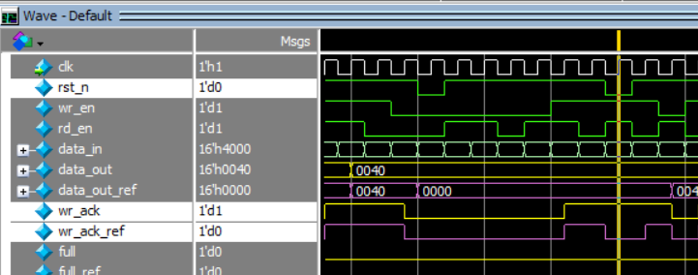

FIX:

    if (!F_if.rst_n) begin

        wr_ptr <= 0;

        F_if.wr_ack <= 0; //

    end

**/// ** Bug_2: The signal overflow is sequential so it must be reset to zero when reset is activate ** ///**



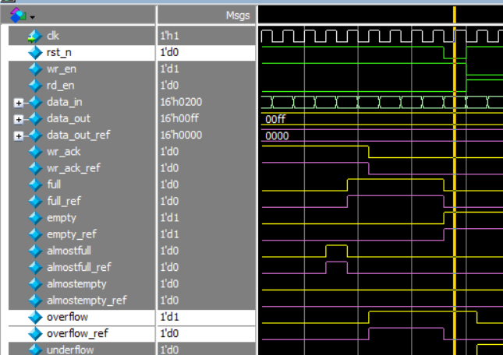

Fix:

    if (!F_if.rst_n) begin

        wr_ptr <= 0;

        F_if.wr_ack <= 0; //

        F_if.overflow <= 0; //

    end

**/// ** Bug_3: The data_out bus is sequential so it must be reset to zero when reset is activate ** ///**



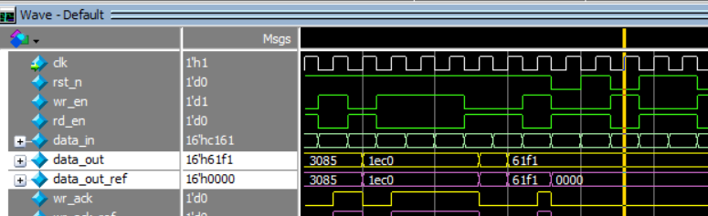

FIX:

    if (!F_if.rst_n) begin

        rd_ptr <= 0;

        F_if.underflow <= 0;// Fix

        F_if.data_out <= 0;// Fix

    end

**/// ** Bug_4: underflow must be sequential not combinational ** ///**

Bug in code:

assign underflow = (empty && rd_en)? 1 : 0;

Bug in waveform:



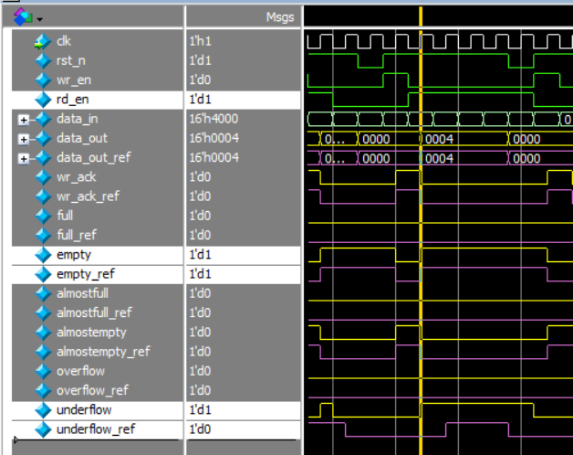

FIX:

    else if (F_if.rd_en && count != 0) begin

        F_if.data_out <= mem[rd_ptr];

        rd_ptr <= rd_ptr + 1;

        F_if.underflow <= 0; // FIX

    end

    else begin // FIX

        if (F_if.empty && F_if.rd_en)// FIX

            F_if.underflow <= 1;// FIX

        else // FIX

            F_if.underflow <= 0;// FIX

    end // FIX

// assign F_if.underflow = (F_if.empty && F_if.rd_en)? 1 : 0; //

**/// ** Bug_4 cont.: The underflow is sequential so it must be reset to zero when reset is activate ** ///**

always @(posedge F_if.clk or negedge F_if.rst_n) begin

    if (!F_if.rst_n) begin

        rd_ptr <= 0;

        F_if.underflow <= 0;// Fix

        F_if.data_out <= 0;// Fix

    end

**/// ** Bug_5: Counter is not handle the case of wr_en and rd_en both are high ** ///**

Bug in code:

always @(posedge clk or negedge rst_n) begin

    if (!rst_n) begin

        count <= 0;

    end

    else begin

        if  ( ({wr_en, rd_en} == 2'b10) && !full)

            count <= count + 1;

        else if ( ({wr_en, rd_en} == 2'b01) && !empty)

            count <= count - 1;

    end

end

Fix:

        if (({F_if.wr_en, F_if.rd_en} == 2'b11) && F_if.full) // FIX

            count <= count - 1; // FIX

        else if (({F_if.wr_en, F_if.rd_en} == 2'b11) && F_if.empty) // FIX

            count <= count + 1; // FIX

        else if ( ({F_if.wr_en, F_if.rd_en} == 2'b10) && !F_if.full)

            count <= count + 1;

        else if ( ({F_if.wr_en, F_if.rd_en} == 2'b01) && !F_if.empty)

            count <= count - 1;

**/// ** Bug_6: almostfull is high when internal signal “count” is less than FIFO_DEPTH by one** ///**



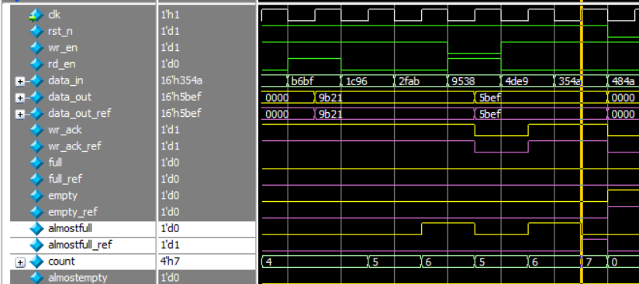

assign almostfull = (count == FIFO_DEPTH-2)? 1 : 0;

Fix:

assign F_if.almostfull = (count == FIFO_DEPTH-1)? 1 : 0; //

**/// ** Bug_7: overflow** ///**

FIFO is full => inputs( wr_en = 1, rd_en = 1) then overflow gets high and FIFO no longer full

At next clk cycle inputs( wr_en = 1, rd_en = X) write operation will succeed but overflow still high



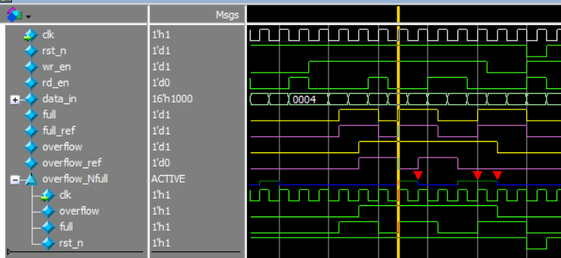

Fix:

    else if (F_if.wr_en && count < FIFO_DEPTH) begin

        mem[wr_ptr] <= F_if.data_in;

        F_if.wr_ack <= 1;

        wr_ptr <= wr_ptr + 1;

        F_if.overflow <= 0; // FIX

    end

**/// ** Bug_8: in if condition should be “&&” not “&” only to achieve 100% Condition Coverage** ///**

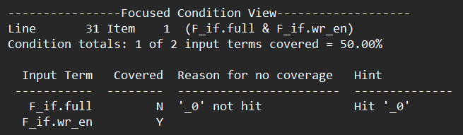

        if (F_if.full & F_if.wr_en)

            F_if.overflow <= 1;

Fix:

        if (F_if.full && F_if.wr_en)// FIX

            F_if.overflow <= 1;

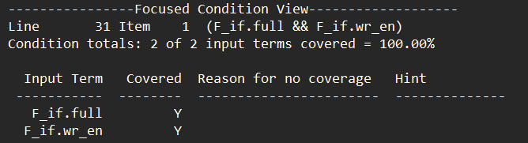

**/// ** Bug_9: when rst_n is activated then empty signal must be zero** ///**



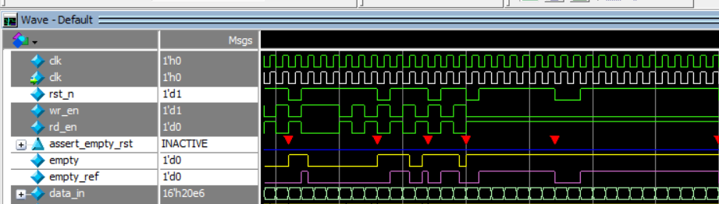

Fix:

assign F_if.empty = (count == 0 && F_if.rst_n)? 1 : 0; // FIX

|  |  |
| --- | --- |
| Bugs report summary. | |
| 1. wr_ack | reset when reset is activated |
| 1. overflow | reset when reset is activated |
| 1. underflow | Add instruction to make it sequential. |
| 1. underflow | reset when reset is activated |
| 1. data_out | reset when reset is activated |
| 1. count | Adding case when wr_en and rd_en are high |
| 1. almostfull | High when count less than FIFO_DEPTH by 1 not 2 |
| 1. overflow | Must get low when full is zero |
| 1. If statement | Should be “&&” not “&” |
| 1. empty | empty must get low when reset is activated |

**Questa Snippet:**

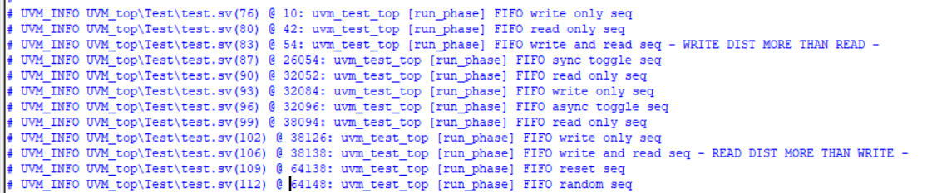

1. Activate reset at the first 5 cycle.

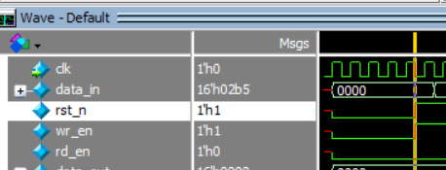

2. LOCK RESET

3. Write only to make FIFO full.

4. Write when FIFO full

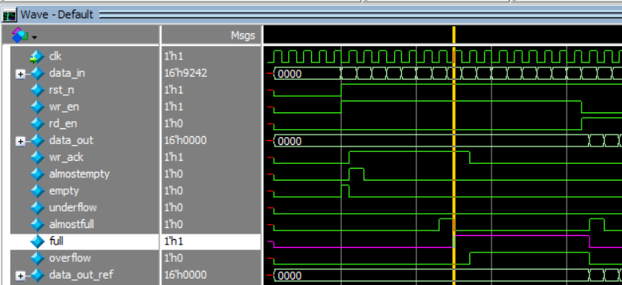

5. Read times less than FIFO_DEPTH.

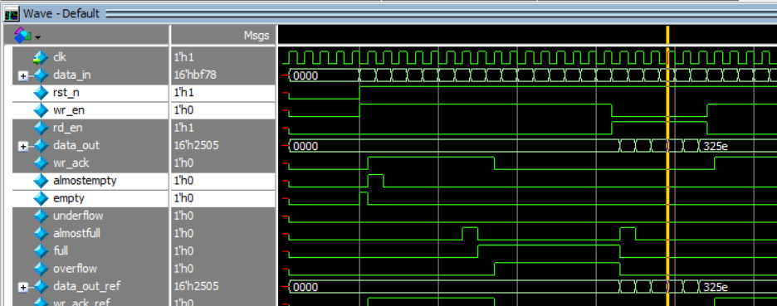

6. read and write constraint `WRITE DIST MORE THAN READ`.

- the first loop to make data_in constraint one bit high

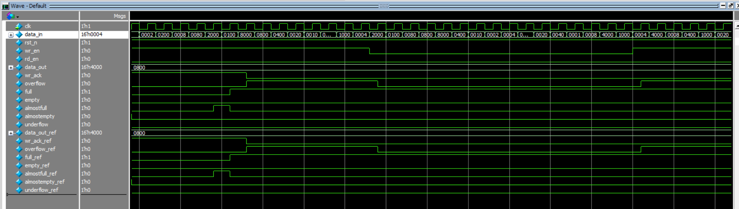

- the seconed loop with no constraint at data_in

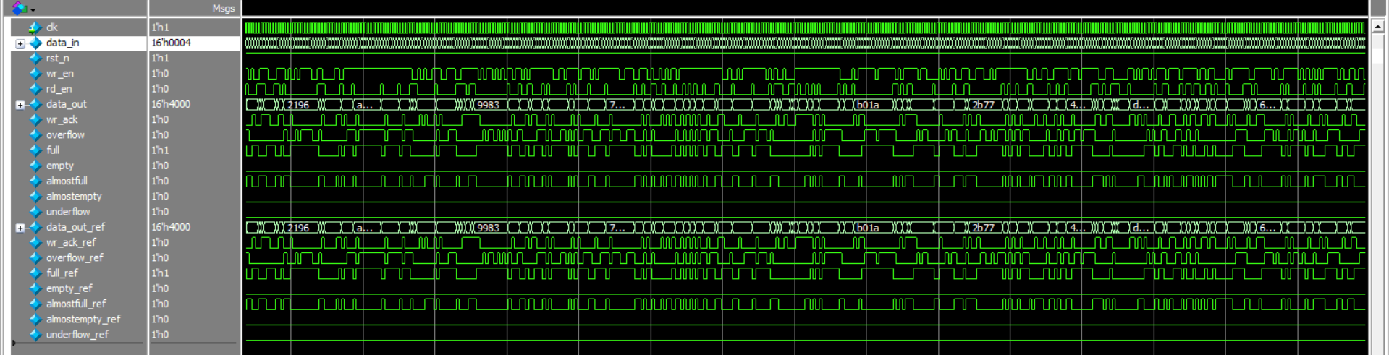

7. Apply Sync toggle => read and write will be equal but they are not equal to the same value twice in a row.

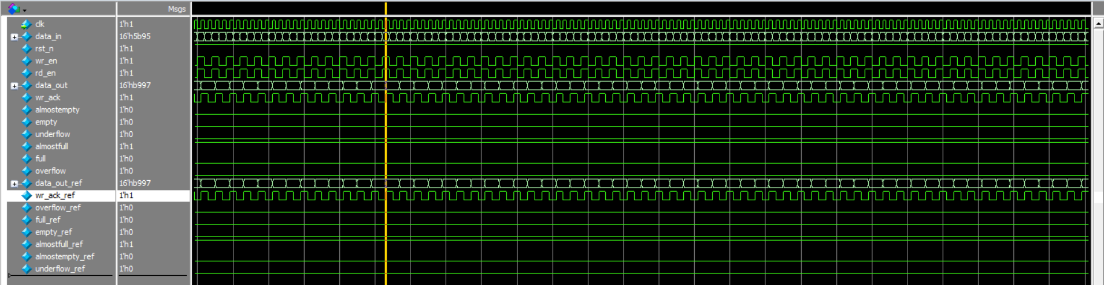

8. Read only to make FIFO empty.

9. Read when FIFO empty.

10. **Write only to make FIFO before full.**

11. Apply Async toggle => read and write will be not equal but they are not equal to the same value twice in a row.

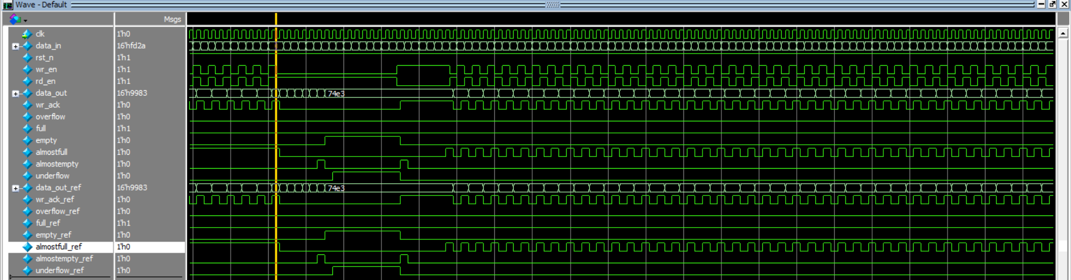

12. Read Only.

13. write Only.

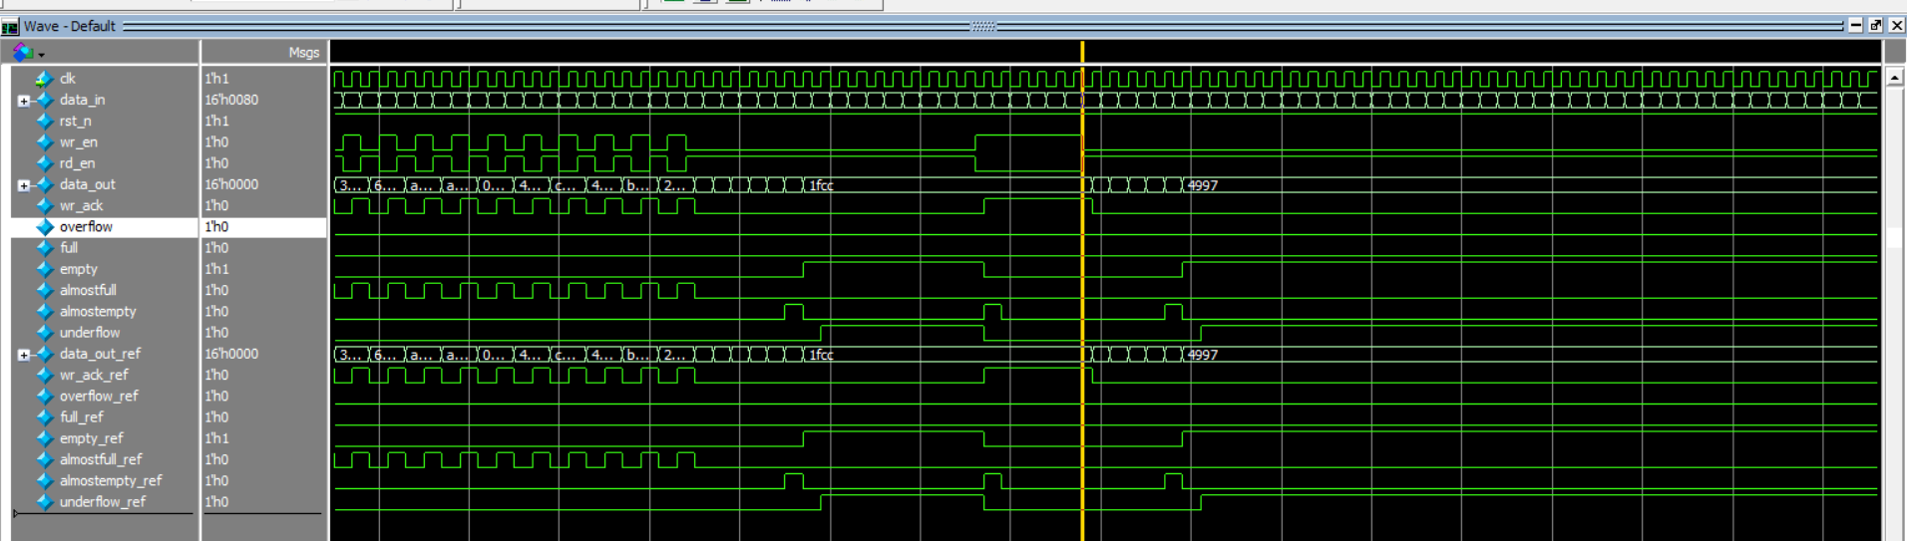

14. UNLOOK RESET

15. Apply read and write at the same time `WRITE DIST LESS THAN READ`.

- the first loop to make data_in constraint one bit high

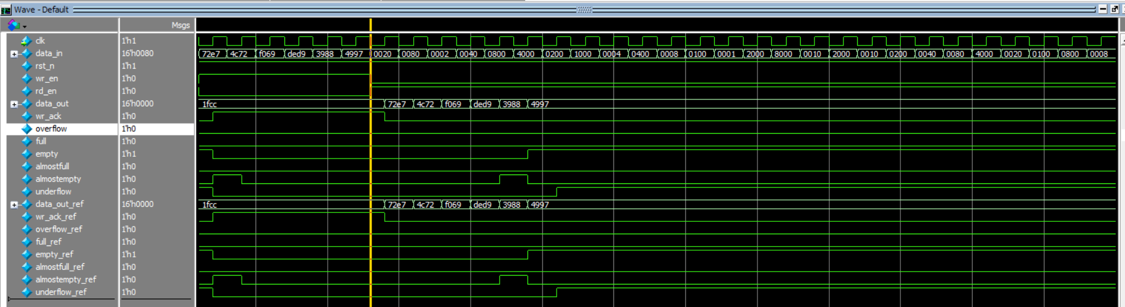

- the seconed loop with no constraint at data_in

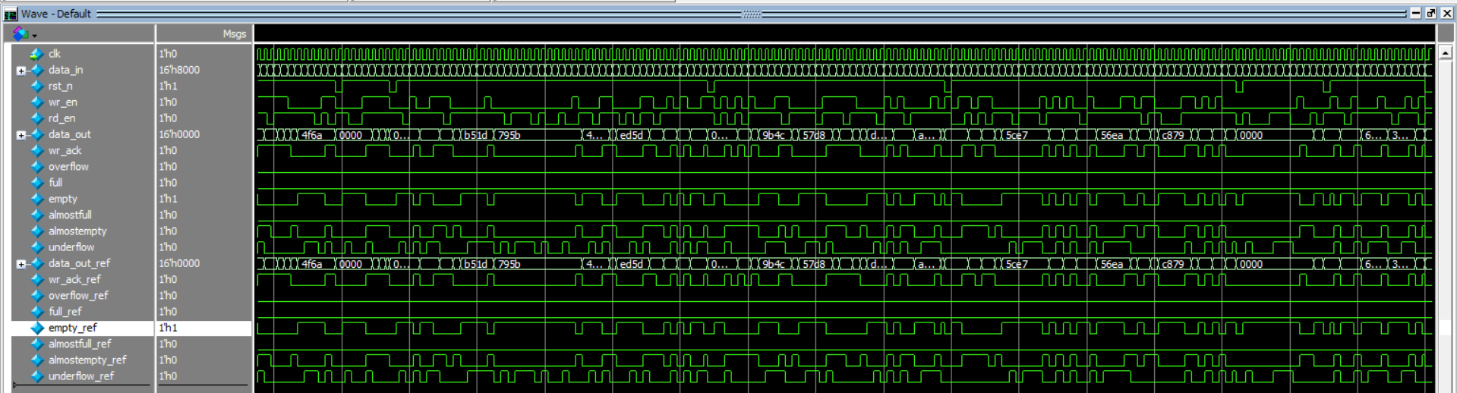

16. Activate reset.

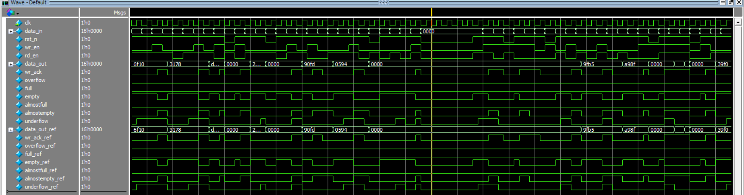

17. Randomization with no Constraint.

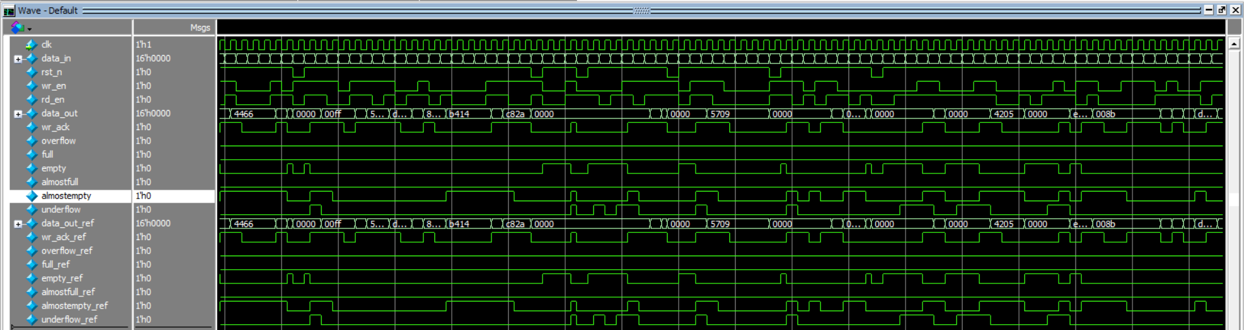

**/// Summary at the end of simulation ///**

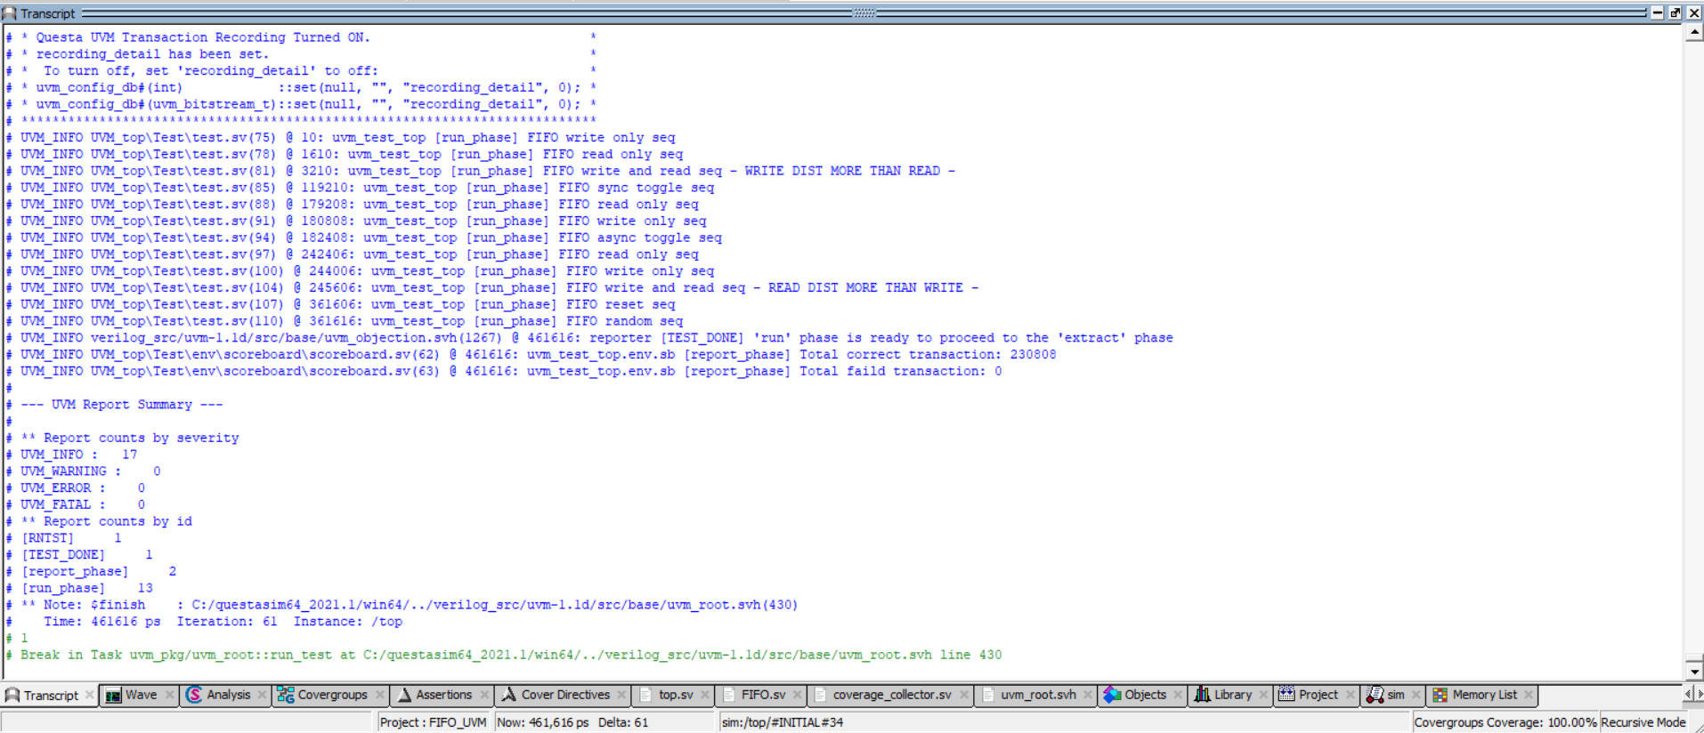

**/// Assertion ///**

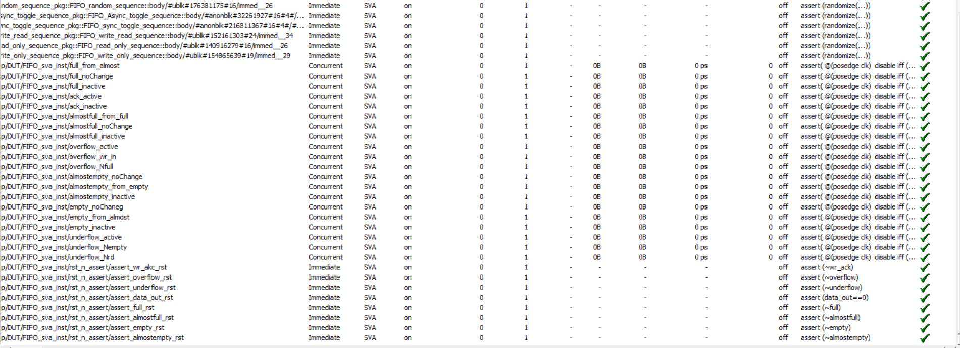

**/// Coverage directive ///**

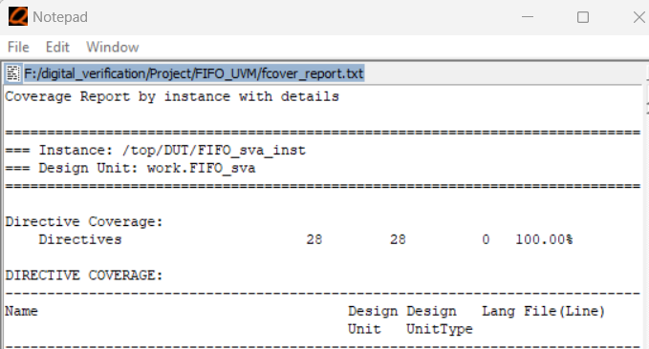

**There is cross coverage when it’s zero, it makes me sure my design behave well Like:**

**1. wr_ack will not be active in case of wr_en is inactive**

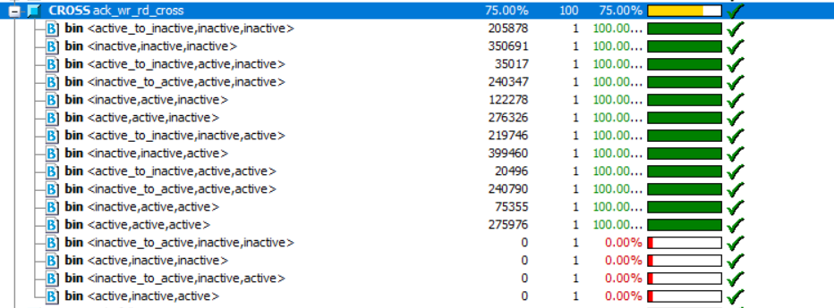

**2.empty flag will not activated when rd_en is inactive**



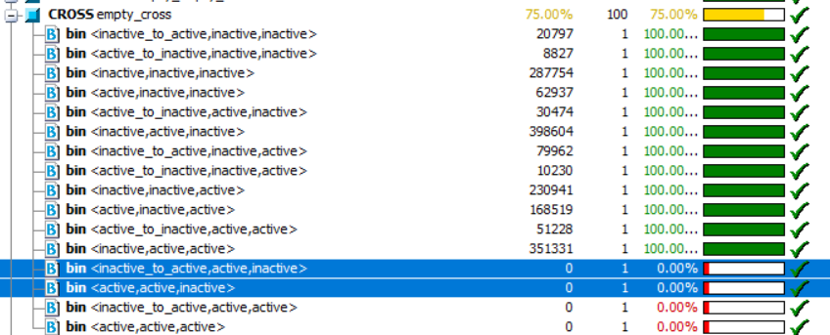

**3. almostempty cant trans from inactive to active while read and write is inactive and the same for almostfull**

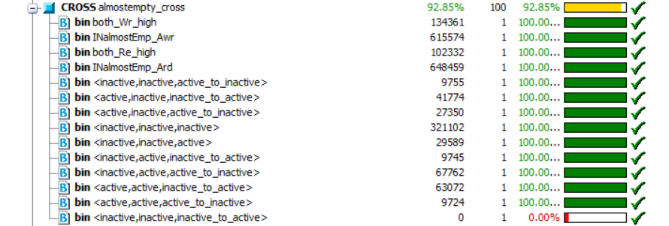

**/// Coverage ///**

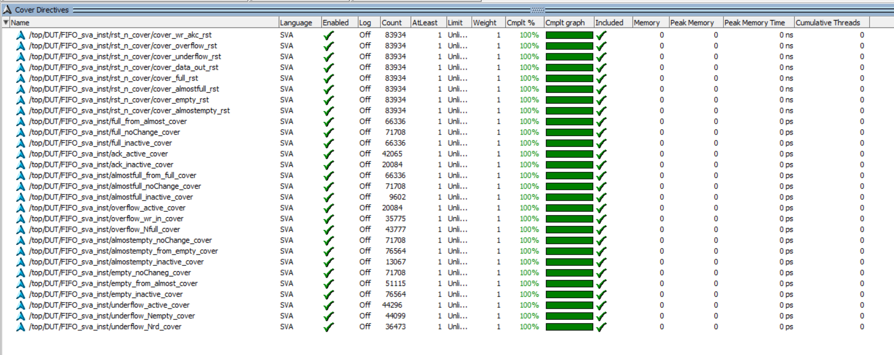

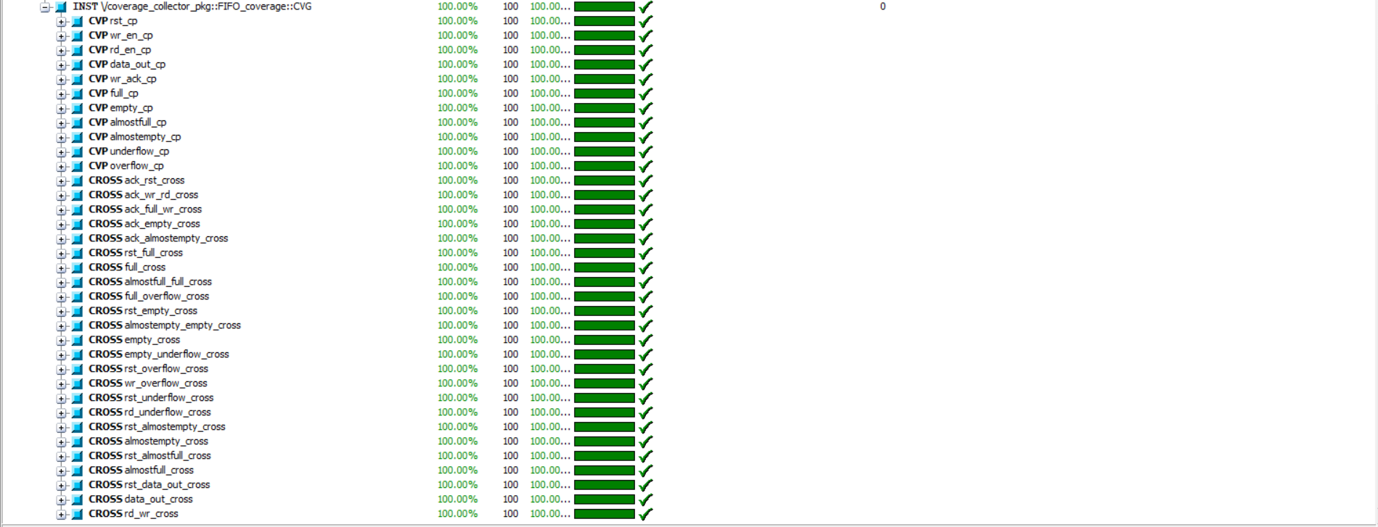

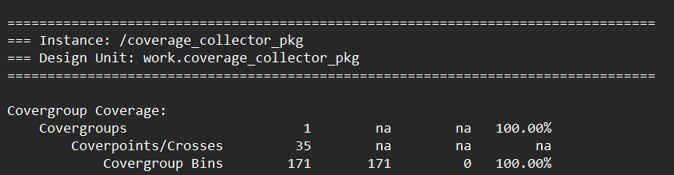

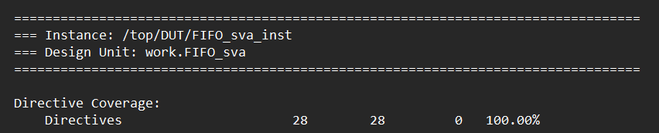

**/// Code Coverage Summary ///**

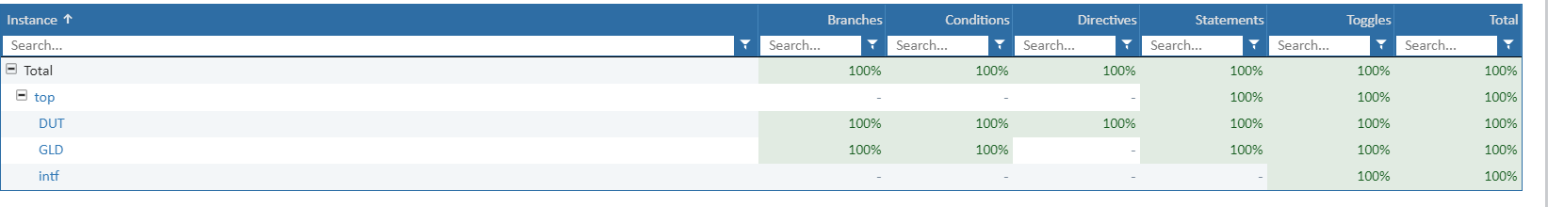

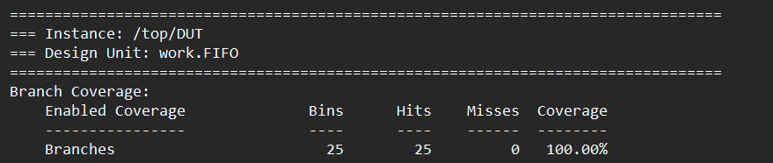

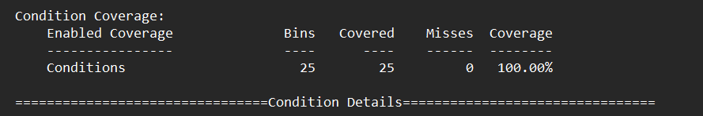

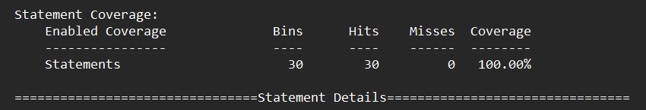

FIFO_interfase toggle for all signals (inputs and outputs)

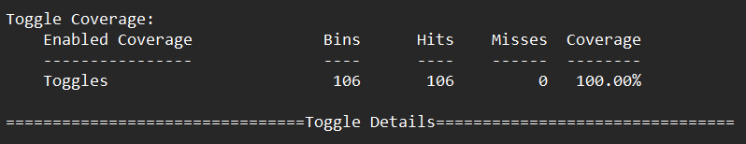

FIFO_sva

